Lake Ōkāreka: Upgrades, management and operation of the lake level controls
27 Feb 2018: Andy Bruere Lake Operations Manager.
Introduction:
In September 2017, Lake Ōkāreka reached its highest level since 1965 at a peak of 354.56m. The highest levels of the 1960s were up to 1.8m above this peak level, as at that time there was no lake outlet and it was these high levels that motivated the need to install a pipeline during the early 1960s.

At the risk of further increasing lake levels in June 2017, BOPRC were motivated to take action to address the rising lake levels. The peak level in September 2017 came within 380mm of the floor level for two houses on Acacia Road. The actions included increasing the outlet pipe flow to a maximum flow of 360 L/s (121 L/s above resource consent conditions of 239 L/s) and install a temporary above ground pipeline and pumping system to augment the gravity pipeline flow to a total of 500L/s. The additional flow was authorised by activation of S330 RMA, emergency works, by BOPRC pursuant to its role as a local authority with control over infrastructure.
Lake Ōkāreka has a 400 mm operational control band and staff use an operation guideline to regulate lake levels. The most disturbing aspect of the event over 2017 peaking in the high lake level during September was that the lake was close to its lower control level during February and three heavy rainfall events during February, March and April conspired to take control of the lake level and overwhelmed BOPRC ability to manage it within the normal consented control range. This and another rainfall event during January 2018 have indicated that there is a high level of uncertainty about how we may be able to manage lake level into the future and that there is a clear risk of exceedances of the maximum consented lake level and potentially a risk of flooding houses in the Ōkāreka village. The attached graph of Lake Ōkāreka water levels illustrates the points made above.
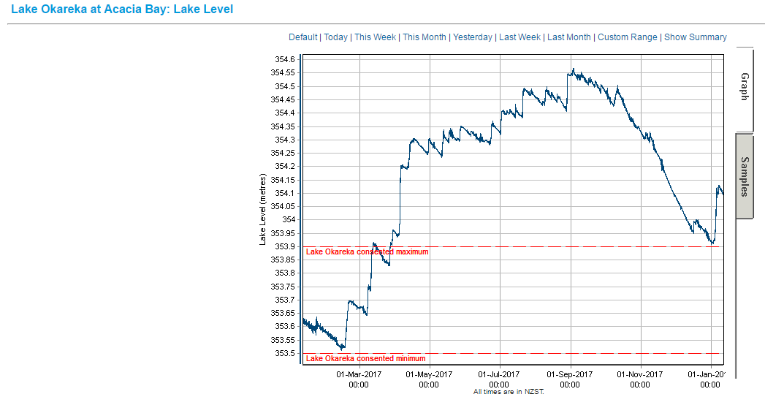
This report is aimed at setting out the BOPRC objectives for managing the lake level and how the lake will be managed with a view of consulting with the community.
- Operational Management Plan:
The flow from Lake Ōkāreka is managed according to the resource consent and associated guidelines for operation, attached as Appendix 1 and 2. The guidelines for operation were upgraded in 2016, having regard to recommendations from engineer Peter West. However, these final guidelines do not manage high lake levels as strictly as West recommended. The table below shows the Summer and Winter operations guidelines and the recommended guidelines from West 2013.
Season | Operation Guidelines 2016 | Lake Level  mRL (Current, 2016) | Lake Level  mRL (West, 2013) | West Recommended Operation Guidelines 2013
Summer | Full Discharge | > 353.8 | >353.75 | Full discharge
Summer | 100 – 150 L/s | 353.75 – 353.80 | 353.75-353.50 | 100 L/s
Summer | 50 L/s | 353.65 – 353.75
Summer | 0 L/s | < 353.65 | < 353.50 | 25 L/s
Winter | Full discharge | > 353.75 | >353.60 | Full discharge
Winter | 100 – 150 L/s | 353.65 – 353.75 | 353.60-353.50 | 100 L/s
Winter | 50 L/s | 353.55 – 353.65
Winter | 0 L/s | < 353.55 | < 353.50 | 25 L/s
Note: 1. operational level is 353.50 – 353.90.
- Full discharge was 239 L/s
The following are details of the pipeline capacity:
- Consented maximum flow 239 L/s
- Max gravity pipe flow 360 L/s (limited by engineering dynamics)
- Max flow with pump and above ground pipe 500 L/s (this is limited by stream capacity and is the desired max flow for emergency consent application)
A memo prepared by West November 2017 outlines scenarios of lake level with different outlet flows ranging from 250L/s to 600 L/s for a 100 year ARI rainfall. See Figure 6 below from the report.
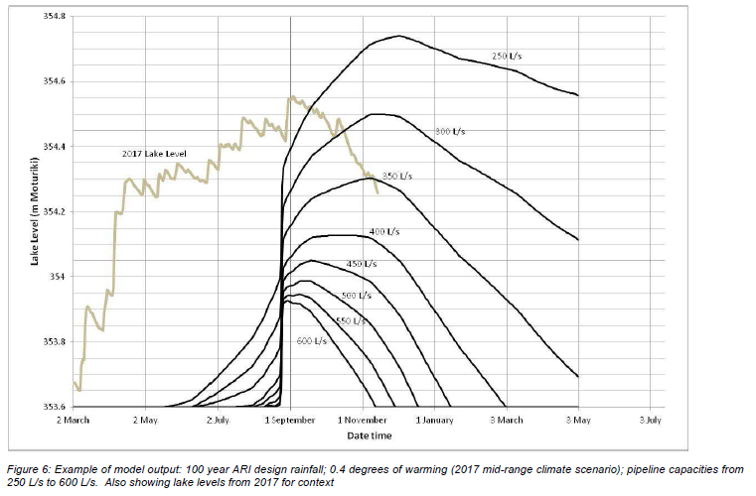
From this figure it can be seen that for all flows except 250 L/s lake level would have been managed below the peak level reached during September 2017. However, it would have involved operating according to the operation guidelines recommended by West 2013. This would mean operation of the full discharge capacity when the lake exceeds 353.60 mRL in winter (ie. When the lake is 300mm below the maximum control level or only 101 mm above the bottom level). Staff have approval from council to apply for resource consent for a gravity pipeline that could discharge 500 L/s. It would not seem appropriate to provide for 500 L/s discharge when the lake is still within the control band and some review of the operation guidelines is necessary to identify appropriate times to increase discharge incrementally. A suggested approach would be such as:
- Do not have specific winter and summer control as summer rainfalls can be extreme due to cyclones,
- Lake level below 353.40 close valve (have additional range to 353.30)
- Lake level below 353.55 discharge 100L/s
- Lake level between 353.55 and 353.65 discharge 170L/s
- lake level exceeds 353.65 discharge 240 L/s
- Lake level exceeds 353.75 discharge 300 L/s
- Lake level exceeds 353.85 discharge 380 L/s
- Lake level exceeds 353.95 discharge 460 L/s
- Lake level exceeds 354.05 discharge 500 L/s
This approach would allow some natural fluctuations in lake level but trigger higher discharge flows as necessary to ensure extremely high lake levels are avoided, as well as reduce the times when the Waitangi Stream is subject to extremely high discharge flows. (Note: these trigger flows need to be assessed, and summer triggers set also). The current operating guidelines and the proposed guidelines are presented in the colour diagram below. The key difference is there will be a much more aggressive approach to lower lake levels and we will be asking for an additional 100mm to the lower end of the range.
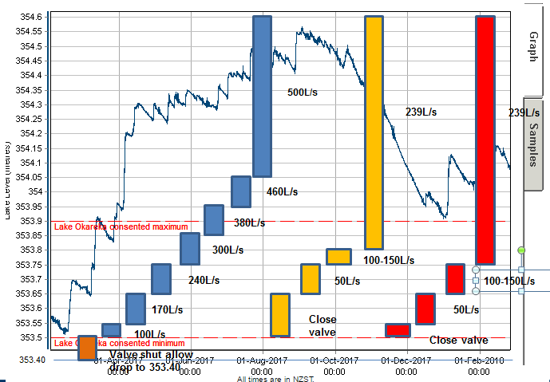
Blue = Proposed guidelines,
Orange = additional 100mm lower,
Yellow = current summer GL’s,
Red = current winter GL’s.
Recommendation: If the main objective of the lake level control is to avoid reaching extremely high lake levels, and where practicable maintain flows below the 500L/s maximum discharge rate then the operation guidelines should be changed to align more closely with the recommended guidelines from West 2013. This will result in a lower lake level on average than currently experienced as well as potential access problems reaching jetties at lower levels.
Some consideration needs to be taken to how quickly flows can be increased and decreased. Discussions with Fish and Game indicate that they would prefer flows being reduced or increased over several stages over a couple of hours. Key times being during trout spawning season or when juvenile fish are present in the stream. The main concern is when reducing flows to below 100L/s will affect stream ecosystem in particular downstream of Spencer Road.
Key Points:
- Model new regime under 2017 weather and climate change predictions,
- Investigate the reason for the current lake level range and low level,
- Understand what peak flow is necessary (500L/s),
- Review GL’s with community, but flexibility remains to adapt at times depending on weather predictions.

- Operational Range:
Current operational range is 400 mm between RL 353.40 and 353.90. A number of rainfall events over the past year have confirmed that a single event over a day or two can increase the lake about ½ the range or more (>200mm). Effects can be compounded when closely spaced events lead to saturated ground conditions which increase the level response to a given event. Staff believe that a larger range is appropriate to enable better compliance with the operational range requirement and provide for adjusting the operation guidelines which will effectively increase discharge flows at a lower level and have the effect of managing the lake to a lower level on average.
Recommendation: In view of this staff recommend testing a larger operational range from 400mm to 500mm in the range 353.30 to 353.90.
This range would also allow for better management of low flows during low lake levels. It would provide for an additional 100mm at low lake level to sustain the residual flow in the Waitangi Stream.
- Short term response:
In some lake level management systems lake levels can be managed in advance of extreme rainfall events. This is due to the manager having the ability to significantly increase discharge flows based on weather forecasts. For Lake Ōkāreka no such control option is available. This is due to the limited outlet capacity of the current and proposed outlet pipe (currently 360 L/s and proposed 500 L/s). It has been observed that with a discharge of 500 L/s a lake level reduction of 12-15 mm/day can be achieved in optimum conditions.
Recommendation: Limited advance management of lake levels is possible for Lake Ōkāreka. The design of the control mechanism will dictate what is possible and this could be included in that consideration.
- Long Term Response:
The current summer-winter approach has been the long term approach to managing lake levels, along with a review of the NIWA quarterly forecasts. This approach is already identified in the operation guidelines. During the summer period the guidelines tend to a slightly higher lake level and during the winter period a slightly lower lake level. The summer period is generally defined as September to March and winter April to August. (Is this appropriate considering that the cyclone season is November to April, when we can get extreme rainfall events?).
Recommendation: The operation guidelines will be used to guide decisions on managing lake level and discharge rates along with weather forecasts. A single operating GL is recommended for the complete year.
- Pipeline upgrade:
In response to the high lake levels of 2017 BOPRC installed a secondary temporary pipeline and pump to augment the lake discharge flows up to 500 L/s. Additional capacity over the 500 L/s was available, but that flow was considered the maximum flow that the Waitangi Stream could withstand without severe erosion failure. During the 2017 event the maximum flow was limited to >500 L/s for that reason.
Environmental modelling of lake level response to a range of rainfalls and in response to climate change was undertaken. A maximum flow of 500 L/s was identified as able to manage up to a 200 ARI event (2090 high range climate change scenario), with the objective of preventing houses within the Ōkāreka community from becoming flooded.
The council has approved funding for a 450 mm pipeline (500 L/s) subject to obtaining resource consent. A number of issues will need to be resolved through this process. The current consent (discharge limit 239L/s) does not provide for sufficient discharge flow to manage high lake levels, particularly when the level exceeds the maximum operating level of 353.90 mRL. This was the basis for invoking the S330 RMA emergency works authorisation for discharge up to 500L/s.
Another issue to resolve is the operational discharge when low lake levels are experienced and you will see there is conflict between the 2017 operation guidelines and the guidelines recommended by West 2013 at low lake level. The 2017 guidelines recommended zero flow and the West guidelines recommend 25L/s (and the consent requires at least 100 L/s flow where practicable). A lower minimum lake level of 353.40 would assist in accommodating a residual flow in the Waitangi Stream to maintain ecological habitat
The engineering consultants have offered two options for the upgraded pipe to the Waitangi Stream:
- Simply upgrade the pipeline to increase discharge to the Waitangi Stream, or
- Upgrade the pipeline with the option of adding power generation at the outlet.
Any decision on this and the specific design should proceed once resource consent is approved. The power generation option would be reliant on an investor interested in taking up that option in some type of partnership arrangement.
Recommendation: Consent be sought for the 500 L/s discharge. No decision on power generation should be made at this stage and this along with pipeline design is progressed once consent is approved.
- Flow Control Options:
The current flow control on the lake is managed by the capacity of several pipes through the embankment between the lake and the canal leading to the pipe inlet (see Figures 1 and 2) and a control valve part way down the current gravity pipeline. The pipes through the embankment are in poor condition and budget is available during the 2018/19 year to replace these pipes with a more suitable structure or mechanism.
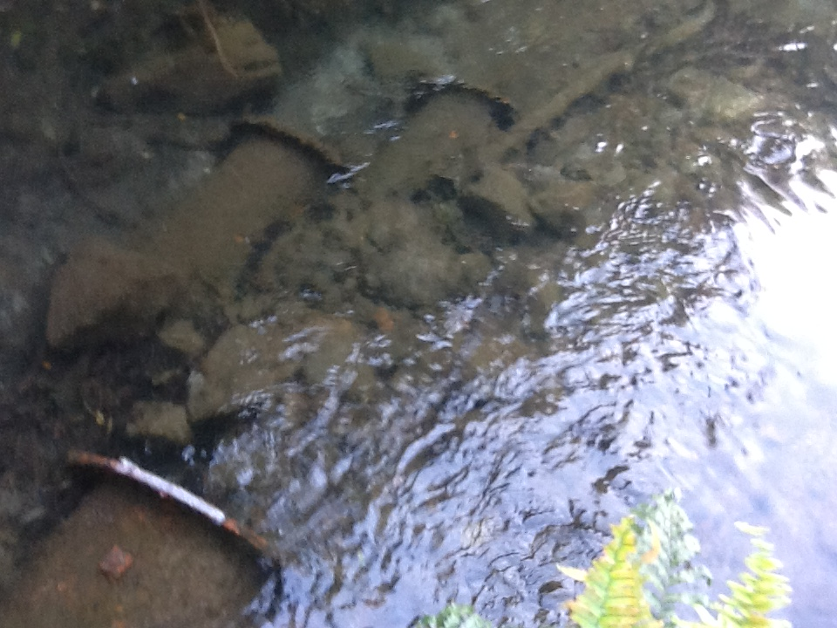
Figure 1. Photo of the inlet pipes between the lake and the pipe channel.
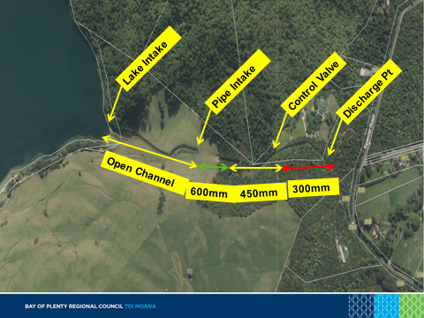
Figure 2. Pipe inlet and pipeline configuration including the location of the temporary pipeline.
It has been proposed that the control could be replaced by a specifically designed weir to meet the requirements of lake level operation. Control of lake levels only by the placement of a fixed weir could be inflexible and staff believe that a more adaptable approach is necessary. Another option includes a purpose built electronically controlled valve into the design of the upgraded pipeline and remove intake pipes and install open box channels. In particular the valve can be easily adjusted, over time as we get further experience under changing weather conditions. The current valve is not well suited to controlling discharge flows. It is a simple gate valve and although there are some guidelines as to settings related to nominal flows, these are inaccurate and can take several attempts to set the appropriate flow. In addition the valve is only controlled manually on site so adjustments take considerable time and then there is a delay until telemetered monitoring confirms the adjusted flow.
Recommendation: Operations staff recommend that the current pipes are removed and replaced with a mechanism which allows implementation of the proposed operating GL’s and allows for future changes to those GL’s. In addition some level of advance management needs to be available so that actions can be undertaken if forecasts show refinement of procedures is necessary.
Note: any decision on this matter is on hold while resource consent is being sought for 500L/s.
- Emergency Consent:
In the circumstances when the lake level rapidly increased and exceeded the maximum lake level (2017) staff recognised a risk that continuing to discharge at the consented flow of 239 L/s could result in flooding some of the low lying houses at Ōkāreka village. As a result they invoked S330 of the RMA and provided discharge capacity up to 500 L/s.
It was thought that by January 2018 we would have the lake back into the control range. However a high rainfall event in early January brought the lake level up by more than 200 mm. As a result staff believe we need to retain the emergency consent until such time as we have long term consent for the 500 L/s to ensure we can respond to high lake levels and address the flooding risk to houses.
At the time of writing the emergency consent was subject to a S92 request for further information. We will continue to pursue the emergency consent.
- Long Term Consent:
As a result of the council decision to fund the upgraded pipeline subject to receiving resource consent, staff have commenced the consent process with the key objective of achieving a consent for up to 500 L/s discharge. In the report to council, staff suggested the following as suitable objective to the lake level control :“Provide lake level management options to council with the aim of better managing the lake to the consented operational range and providing a more rapid return to operational levels in the event of lake level exceedances.“
Assuming this is a reasonable control objective staff intend to apply for a resource consent that allows for a maximum discharge of 500 L/s as well as resolve a number of issues that have already been outlined in this report (operational range, operation guidelines, control mechanisms) This would provide for flood protection of all houses at Ōkāreka within a 200 year ARI event, subject to operation guidelines.
A working party with community and stakeholders has been set up that will be a key part of working through the above options and process of obtaining resource consent. There is currently a clear division between members of the party that support options to enable higher discharge flows and others who are concerned about the impact of higher flows on the Waitangi Stream and Lake Tarawera. There are a number of matters that will need to be resolved through this process.
Consultation will also need to be undertaken specifically with iwi, affected land owners and the communities of Lake Okareka and Tarawera.
The current consent expires in 2026. We will need to consider whether to apply for a new consent or go for a variation to the current consent. There may be some advantage of going for a longer term than up until 2026.
Recommendation: The consent application will be made before 30 June 2018, subject to consultation progress.
- Access and Easement:
To manage and operate the pipeline staff require property access at various times. The main areas for access are directly to the pipeline and outlet structures upstream of Spencer Road, and then access to the Waitangi Stream downstream of Spencer Road.
Access is required for day to day management to the inlet pipes, the pipeline inlet and the control valve. Access is also required to enable any future upgrades. One issue that has been identified in the past is that the pipeline is not completely within the area of the easement. This has the potential to create difficulties in the future, although land owners have been highly cooperative to date with regard to access. It is understood that Unison and Chorus utilise the access track also, it may be worthwhile seeking a collaborative easement with these parties.
Downstream of Spencer Road access is required to enable stream inspection and maintenance works to the stream bank and culverts. BOPRC does not have formal access arrangements for stream works.
Recommendation: advice will be sought on what access rights we have to undertake our work and what changes to these arrangements are necessary.

- Erosion Works, inspection and maintenance:

Current maintenance programme for Ōkāreka includes:
- keeping the inlet pipes from the lake into the channel clear
- keeping the weed screen at the pipe inlet clear
- maintaining the access track surface
- clearing any slips or vegetation from the access track
- spraying intake channel during summer.

The increased flows required over 2017 have identified potential stream bed and bank erosion issues that need regular inspection and some maintenance works. Prior to the 2017 500 l/s discharge, significant works were undertaken in the stream to clear debris as well as protect the stream bed and banks at the advice of an engineer. Most of the works were of a temporary nature due to the need to address the high lake level rapidly and the expectation is that BOPRC will replace all temporary structures with permanent works once we have an appropriate design and we are able to reduce lake discharge flows.
Recommendation: BOPRC ensures it has appropriate access arrangements to inspect and maintain the pipeline and the stream. BOPRC will ensure the stream bed and banks are protected against erosion caused by high stream flows.
- Safety issues:
Some of the structures and water flows associated with the management of the lake level have inherent safety issues. Staff have discussed this issue with our Health and Safety Manager were it is understood that:
- inlet and outlets structures require protection/debris screens
- Fencing/barriers are required around inlet and outlet structures with prevision that someone can get out if they get in
- Simple signage around structures (messages of keep out and risk of changing flows)
Recommendation: Safety items will be addressed by BOPRC.

APPENDIX1. Resource Consent Conditions and Operational Management Plan

Bay of Plenty Regional Council

Resource Consent

Pursuant to section 105 of the Resource Management Act 1991, the Bay of Plenty Regional Council, by a decision dated 15 May 2001, Hereby Grants to:

ENVIRONMENT B·O·P - OPERATIONS & RURAL SERVICES DEPARTMENT

Environment B·O·P
P O Box 364
WHAKATANE

A resource consent:

a) pursuant to section 13 (1)(a) of the Resource Management Act 1991 to Use and Maintain an Existing Intake Structure in the Bed of a Canal from Lake Okareka; and

b) pursuant to section 14 (1)(a) of the Resource Management Act 1991 to Take Water from Lake Okareka; and

c) pursuant to section 13 (1)(a) of the Resource Management Act 1991 to Use and Maintain an Existing Outlet Structure in the Bed of the Waitangi Stream; and

d) pursuant to section 15 (1)(a) of the Resource Management Act 1991 to Discharge Water Into the Waitangi Stream; subject to the following conditions:

Purpose
For the purpose of managing the level of Lake Okareka by taking water from Lake Okareka at a controlled rate of flow, diverting the water through a pipeline, and then discharging to the Waitangi Stream.
Location
The intake (point of water take) is located at the western end of Lake Okareka, and the outlet (point of discharge) is located in the Waitangi Stream, as shown in Figure 2 of Environment B·O·P Operations Report 98/18 submitted with the application for this consent, and identified as being BOPRC Plan Number RC 60776.
Map Reference
The intake is located at or about map reference NZMS 260 U16 0610 3050, and the outlet is located at or about map reference NZMS 260 U16 0640 3050.
Legal Description
Lot 1 DPS 67566 Pt Lot 1 DPS 19175 Block VII Tarawera SD (Rotorua District).
Inlet and Outlet Structures
The consent holder shall ensure that the inlet and outlet structures and immediate environments are effectively protected to prevent any erosion that may result from the exercise of this consent.
The consent holder shall ensure that the inlet, outlet and pipeline structure is operated at all times in accordance with the information provided in the consent application dated 9 May 2000.
Discharge Quantity
The rate of discharge shall not exceed 239 litres per second.
The consent holder shall ensure that a minimum rate of discharge of 100 litres per second is maintained as far as practicable, to contribute to the base flow of the Waitangi Stream.
Discharge Quality
The consent holder shall ensure that, as a result of the discharge, (and disregarding the effect of any natural perturbation that may affect the water body), the receiving water in the Waitangi Stream meets the following water quality standards after reasonable mixing or 30 metres downstream from the discharge point, compared to immediately upstream of the discharge point:
The concentration of dissolved oxygen in the receiving water shall not exceed 80% of saturation concentration,
There shall be no increase in colour as assessed by Munsell hue colour units measurement and no decrease in visual clarity as assessed by black disc measurement,
There shall be no detectable increase in acute chronic toxicity between a water sample above the discharge point and a sample of the discharge diluted with that water 30 metres downstream from the discharge point,
There shall be no increase in temperature of more than 3°C, and the maximum temperature shall not exceed 25°C,
The pH of the receiving water shall not be lower than 6.5 or greater than 8.5,
There shall be no production of conspicuous oil or grease films, scums or foams, or floatable or suspended materials,
The seasonal maximum cover of stream and river beds by periphyton as filamentous growths or mats (>ca.3mm thick) shall not exceed 40 percent, and/or biomass shall not exceed 100 mg chlorophyll-a /m² of exposed surface area, and any change in bacterial and/or fungal slime growths shall not be conspicuous,
Aquatic food resources shall not be rendered unsuitable for human consumption, nor water rendered unsuitable for stock watering,
There shall be no increase in the emission of objectionable odour.
Management and Maintenance of the Lake Level Control Structures
The consent holder shall operate the inlet, outlet and pipeline structure to achieve the most effective lake level control for Lake Okareka, within the target range of 353.5 metres minimum lake level (Moturiki datum) and 353.9 metres maximum lake level (Moturiki datum).
The consent holder shall submit a report to the Director Regulation and Monitoring of Environment BOP setting out guidelines that will be followed for the effective day to day management of the inlet, outlet and pipeline structure to achieve optimum control over the target range for the Lake Okareka lake levels. The report shall be forwarded no later than 30 September 2001, and include, but not be restricted to:
Schedule for regular checking of lake levels; and
Schedule for regular checking of screen intake; and
Guidelines for setting of valve in response to lake level readings; and
Responsibilities for carrying out the day to day management; and
Provision for regular review of the day to day operational guidelines.
The consent holder shall ensure that the intake, pipeline, outlet, and associated lake level control structures are maintained in an effective capacity at all times during the term of this consent, and shall undertake any maintenance work required to address any adverse environmental effects as soon as practicable if so directed by the Director, Regulation and Monitoring of the Regional Council or delegate.
Control of Unwanted Pest Species or Organisms
The consent holder shall set up a Management Plan in conjunction with other relevant authorities for monitoring for, and responding to the presence of unwanted pest species or organisms in Lake Okareka. The Management Plan shall be forwarded to the Regional Council prior to 31 December 2001.
Mitigation
The consent holder shall prepare a management proposal for the protection of the margins of the inlet canal in conjunction with the landowners of the property and forward a copy of the proposal to the Regional Council prior to 31 December 2001. The proposal shall include funding assistance available under Regional Council policies for the landowners to undertake environmental protection work should they wish to proceed with the protection of the inlet canal from stock grazing.
Monitoring Recording and Reporting
The consent holder shall set up a water quality monitoring programme for the inlet canal and present the programme prior to 30 September 2001 for approval by the Director, Regulation and Monitoring of Environment B·O·P. The monitoring programme shall include (but not be restricted to) the following:
Monitoring of nutrients (nitrogen and phosphorus); and
Monitoring of bacteria; and
Monitoring shall be undertaken at suitable regular intervals and will include monitoring during periods of heavy rainfall.
The results of the monitoring programme shall be summarised and forwarded to the Regional Council prior to 30 September each year, with the first annual report due by 30 September 2002.
The consent holder shall inform the Regional Council and provide appropriate details as soon as practicable if the following occurs:
If the rate of discharge falls below the minimum 100 litres per second; and
If the pipeline has to be closed off for any specific reason; and
When normal flow through the pipeline resumes.
Review of Conditions
The Regional Council may, during the month of September in the year 2005, and every three years thereafter, serve notice on the consent holder under section 128(1)(a)(i) or (iii) of the Resource Management Act 1991, of it’s intention to review condition 11 of this consent. The purpose of the review is to ensure that condition 11 would continue to provide an appropriate monitoring programme for the duration of the consent.
Term of Consent
This consent shall expire on 31 May 2026.
Resource Management Charges
The consent holder shall pay the Bay of Plenty Regional Council such administrative charges as are fixed from time to time by the Regional Council in accordance with section 36 of the Resource Management Act 1991.
The Consent hereby authorised is granted under the Resource Management Act 1991 and does not constitute an authority under any other Act, Regulation or Bylaw.

Advice Notes:

- The consent holder is advised that non-compliance with consent conditions may result in enforcement action against the consent holder and/or their contractor(s).

- The consent holder is responsible for ensuring that all contractors or operators carrying out works, management or maintenance under this consent are made aware of the relevant consent conditions, plans and associated documents.

- Notification/advice requirements pursuant to conditions 8, 9, 10 and 11 shall be directed (in writing) to the Principal Compliance Officer, Environment B·O·P.

DATED at Whakatane this 10th day of March 2003

For and on behalf of
The Bay of Plenty Regional Council

J A Jones

Chief Executive

APPENDIX 2.
Lake Ōkāreka Outlet – Guidelines for Operation of Structure (August 2016)
1. Introduction
Lake Ōkāreka has no natural outlet and outflow is controlled by a valve on a pipe
that discharges into the Waitangi Stream (which flows into Lake Tarawera).
BOPRC holds consent #60776 for this structure, granted in May 2001 and
expiring in 2026. Condition 8.2 of the consent includes a requirement for
Guidelines for setting of the valve in response to lake level readings
2. Target Range
Condition 8.1 gives the target range for the lake level as 353.5m to 353.9m
(Moturiki Datum 1953). The rate of discharge in the Waitangi Stream shall not
exceed 239 litres per second (Condition 6.1) and as far as practicable have a
minimum discharge rate of 100 litres per second (Condition 6.2).
3. Day-to-day management
Responsibility for day-to-day management of the outlet structure is delegated to
the Bay of Plenty Regional Council’s Engineering team.
4. Monitoring of Lake Level
Lake levels are to be checked at least weekly by BOPRC’s Engineering team.
Daily lake levels can be viewed from the telemetry data on BOPRC’s Live
Monitoring website.
5. Regular Checking of Pipe Intake
The trash rack above the intake structure traps debris. The trash rack is to be
checked and cleared weekly when the valve is partially or fully opened. The
pipes between Lake Ōkāreka and the canal (above intake structure) will be
checked and cleared at the same time as the intake by a local contractor
organised by BOPRC.
6. Other Considerations
Any adjustment of the pipeline valve, i.e. changes to the rate of outflow into
Waitangi Stream, will be made after consultation with Fish and Game New
Zealand. Fish and Game New Zealand require flow in the Waitangi Stream from
April to the beginning of December. 303 Spencer Road through which the
Waitangi Stream runs contains a trout fishery. The peak of the trout spawning
season is from May – July inclusive, with eggs hatching August – September.
and rearing is usually complete by the beginning of December. February and
Lake Ōkāreka Outlet – Guidelines for Operation of Structure – August 2016 2
March is the period when the juvenile fish move out of the stream mouth into the
lake. If the valve does require closing prior to December, Fish and Game would
prefer this to be done in graduated steps.
7. Valve Operation Guidelines
The valve will be adjusted as needed according to Figure 1 attached.
Figure 1 shows that there shall generally be four settings:
· fully closed
· open at approximately 50 l/s
· open at approximately 100 - 150 l/s
· open valve to 8.5 turns (approximately 239 l/s)
Discretion is available to vary the settings as considered appropriate to meet the
objectives of maintaining lake levels within the target range and flows in the
Waitangi Stream for fish habitat protection.
8. Communication
The Engineering team (consent holder) shall advise BOPC’s Consents team
under Condition 11.3 if:
· the discharge into Waitangi Stream falls below the minimum 100 litres per
second
· the pipeline has to be closed off for any specific reason
· when flow through the pipeline resumes.
Interested parties will be advised of any adjustment of the pipeline valve, (i.e.
changes to the rate of outflow into Waitangi Stream) via the @Okareka Pipeline
Operation group email. Interested parties include:
· Fish and Game New Zealand
· Department of Conservation
· Lake Ōkāreka residents
· Applicable Rotorua Lakes Council and BOPRC staff
· Three Lake Tarawera properties with water takes from Waitangi Stream
(includes 303 Spencer Road)
· Others requesting to join group email
Out of consideration for the downstream properties with water takes, it is helpful
to give 1-2 days warning of valve adjustments (particularly closing of the valve or
resuming flow).
7. Monitoring and Review of Guidelines
The operational guidelines shall be reviewed every five years (or earlier as
required) by the Bay of Plenty Regional Council (the consent holder).
Lake Ōkāreka Outlet – Guidelines for Operation of Structure – August 2016
