**To Bay of Plenty Regional Council**

**Resource Consent Application to;**

* **Increase the Water Discharge Rate from Lake Okareka to a Maximum of 500 Litres/second by increasing the flow through the existing pipe system and add a second pipe and pump or replacing both with a single pipe at a later date.**
* **To Undertake Short Term and Long term Stream Protection works in the Waitangi Stream**

**13th January 2019**

**Index**

**1.0 Introduction**

1.1 Location

1.2 Historic Background

1.3 Project Background

1.4 Proposal

1.5 Alternatives

1.6 Regional Plan Rules and Resource Consents Required

**2.0 Site Description**

2.1 Activity Site

2.2 Adjacent Properties

2.3 Easement

2.4 Legal Title

2.5 Site Access

**3.0 Description of the Discharge System**

3.1 Description of the original gravity pipe system

**4.0 Description of the Environment**

4.1 Physical Environment

4.2 Ecological Assessment

4.3 Water Chemistry

4.4 Recreational Values

4.5 Lake Level Management June 2017 to October 2018

**5.0 Engineering Assessment**

5.1 Engineering Works

5.2 Monitoring

**6.0 Discharge Management Plan**

**7.0 Assessment of Environmental Effects**

7.1 Water Quality

7.2 Additional Water Take and Discharge Structures

7.3 Additional Flow -Physical Effects on Waitangi Steam and Downstream

7.4 Culverts

7.5 Fish and Macro-invertebrates

7.6 Minimum Flow Rates

7.7 Potential for transfer of pests from Lake Okareka to Lake Tarawera via the pipeline control system

7.8 Recreation

7.9 Visual Impact

7.10 Summary of Environmental Effects

**8.0 Cultural Values**

**9.0 Consultation and Information Distribution**

9.1 Consultation Objectives

9.2 Parties Consulted

9.2.1 Emailed updates to residents and on BOPRC website

9.2.2 Affected Parties Adjacent to Waitangi Stream

9.2.3 Tuhourangi Tribal Authority

9.2.4 Ngati Rangitihi

0.2.5 Te Arawa Lakes Trust

9.2.6 Lake Okareka Community Association

9.2.7 Lake Tarawera Ratepayers Association

9.2.8 Eastern Region Fish and Game

9.2.9 Rotorua Lakes Council

9.2.10 Tarawera Lakes Protection Society

9.2.11 Department of Conservation

9.2.12 Lake Okareka Working Party

9.3 Consultation Outcomes

**10.0 Relevant Legislation and Plans**

**11.0 Summary**

**References**

**Appendices**

**Appendix 1 Maps and Photographs**

**Appendix 2 Resource Consent Application Forms**

**Appendix 3 Engineering Report and Operating Guidelines**

**Appendix 4 Consultation**

**Appendix 5 Water Quality Analysis**

**Appendix 6 Current Resource Consent**

**Appendix 7 Ecological Reports**

**Appendix 8 Archaeological Report**

**Appendix 9 Relevant Legislation and Plans**

This Consent Application and AEE should be read in conjunction with the maps, graphs and photographs contained in Appendix 1. Note that all figures in this summary are also reproduced in Appendix 1 and can be printed in full page format. Other quoted reports and references are contained in the listed appendices which also form part of the resource consent application.

**1.0 Introduction**

**1.1 Location**

Lake Okareka is a small lake in the Rotorua District situated between Lake Tikitapu and Lake Tarawera (Appendix 1 Figs 1-3). It has a surface area of 3.46 km2, a land catchment area of 19.8 km2, and a maximum depth of 33.5 metres. The lake is regarded as mesotrophic, which is intermediate between oligotrophic (low in nutrients, generally in 'natural' condition), and eutrophic (high in nutrients, typical of a highly modified or pastoral catchment).

**1.2 Historic Background**

In the early 1960s Lake Okareka had no surface outlet and in 1963 it reached its highest recorded level of 356.3m. This caused significant flooding of properties and lead to the constructed of a surface outlet and later a pipe system which is currently in place. Over the years since installation, the pipe has been modified and upgraded. In September 2017, Lake Ōkāreka reached 354.56m which was its highest recorded level since the 1963 peak. The 1963 level was 1.8m above the September 2017 peak level (Appendix 1 Figs 8 and 21).

Events in 2017 and subsequent modelling shows that the current pipe configuration and consent discharge limit of 239L/s was unlikely to have the capacity to discharge the water volumes resulting from large and more numerous rainfall events, particularly when climate change is factored in. The 2017 events lead to flooding of the lakeside margins and damage to lakeside paths and structures and risk to dwellings. Without intervention to increase the discharge flow the lake level would have continued to increase and it is highly likely that it would have resulted in damage to property.

In June 2017 Bay of Plenty Regional Council invoked s330 of the Resource Management Act to increase the discharge for Lake Okareka to 360 L/s through the existing pipe and to add a second pipe and pump to give a total discharge rate of up to 500L/s and to undertake stream protection works to prevent erosion caused by the increased flow. This resource consent is currently in place.

It is proposed that the emergency works consent will remain in place until this long term consent is granted.

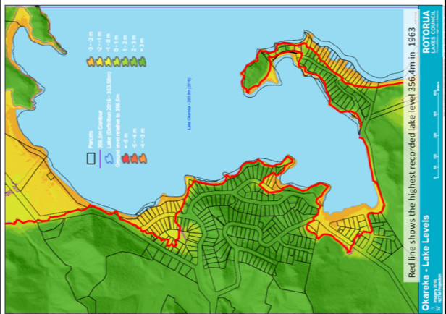

Fig 1 Flooding (red line) resulting from the record lake level of 356.4m in 1963.

(Appendix 1 Fig 9)

**1.3 Project Background**

The outflow from Lake Okareka discharges into the headwaters of the Waitangi Stream which flows into Lake Tarawera. Bay of Plenty Regional Council (BOPRC) holds resource consent (No 60776 issued in 2001 (Appendix 6) to discharge water from the Lake Okareka outlet canal into the Waitangi Stream at a maximum rate of 239L/s. This consent has been temporarily superseded by an emergency works consent operating under s330 of the RMA. Until May 2017 the rate of discharge was regulated by a pipe system with inline valve which controlled the discharge flow rate of between 100L/s and 239L/s to maintain the lake level within a consent target range of 353.5 to 353.9 metres.

Since February 2017 the region has been hit by a number of major rainfall events interspersed with smaller events which elevated lake level to its highest since the outlet control structures were installed in 1965.

Between 1 March and 13 July 2017 (144 days) there were 15 days with rainfall exceeding 50mm/day and 6 days exceeding 100mm/day. The events during the period February to September 2017 equal to or exceed 100 year events for up to 150 day duration, 50 year events for 150-250 day duration and a 15 year event for 300 day duration. (Source West 17/11/17).

Appendix 1 Figs 20 and 23 shows that on 13 February 2017 the lake level was close to the lower consent limit of 253.5m. It reached the upper consent limit on 13th March and exceeded the upper consent limit by 404mm on 17 April 2017. The lake reached its highest level in the current event on 3 September 2017 at 354.56m (666mm above the consent maximum target).

The discharge is controlled by a pipe with a valve which has a maximum discharge capability of approximately of 360L/s. The control valve had been operating at the maximum resource consent limit (239L/s) since 19th March 2017. Opening the valve to full capacity could reduce the lake level by approximately 5mm per day if there is no rainfall. With average rainfall the lake level will reduce by approximately 1mm per day. Clearly this wasn't sufficient to reduce the level of the lake and given current weather patterns, it was deemed likely that the level could increase further. Within the current discharge system, there is no way of increasing the discharge rate beyond the current 360L/s. This was not sufficient to maintain the lake level below the upper limit, so on 23rd June 2017 under s330 of the Resource Management Act (Emergency Works), BOPRC applied for the valve to be opened to its maximum physical capacity of 360L/s and for the addition of a pump and second pipe to increase discharge capacity to a maximum of 500L/s.

Under s330 of the RMA, BOPRC added a second discharge pipe (450mm diameter) and pump system to convey water from the current outflow channel to discharge next to the existing dissipater into the Waitangi Stream (Appendix 1 Figs 10-15). The second pipe increased the potential flow by 140 L/s to a combined maximum to 500L/s. Once the lake level was close to the consent range, the pump was turned off and the discharge rate was reduced. With the valve fully open, the flow will only reach 360L/s if the lake level is at or above the consent target maximum of 353.9m

BOPRC is now seeking a long term resource consent to continue to operate under the discharge parameters contained in the emergency consent, i.e. to use the original discharge pipe with a maximum capacity 360 L/s and to retain the parallel pipe to provide a combined discharge capacity of up to 500L/s. It should be noted that since the current resource consent was issued (March 2003) the consented flow limit of 239L/s has been adequate to maintain the lake level within the range 353.3m to 353.9m for most of the time and where this was exceeded, there was no damage to dwellings, so it is likely that the outflow will generally operate within the currently consented range, but the additional physical and consented discharge capacity will ensure that lake levels are unlikely to reach recent high levels with potential risk to property. With the increased discharge potential and under the proposed guidelines, the lake level will not exceed that of September 2017 using current climate predictions or the 2040 climate change predictions. Modelling indicates that the level will only exceed the September 2017 level using the 2090 'High Range' climate change scenario. (West 2018 Table 8).

At that time of the s330 application, three flow scenarios were considered assessing the time for the lake level to reduce from the level of 354.38m at 12.00 on 20/07/17 to the maximum target consent level of 353.90m which is a fall of 480mm.

1. Current Consent limit (239L/s)
2. Current Valve Fully Open (360L/s)
3. Addition of a second pipe to increase total flow capacity to 500L/s

Without considering further rainfall the lake level was predicted to fall by the following:

a. Discharging under the current resource consent limit of 239L/s, the lake level will fall by approximately 3-4mm/day, taking approximately **137 days** to reach the consent maximum level of 353.9m

b. Under 360L/s operating conditions the lake level will fall by approximately 5mm/day, taking approximately **96 days** to reach the consent maximum level of 353.9m

c. Under the proposed increased flow rate of 500L/s the lake level will fall by approximately 6-7mm/day, taking approximately **74 days** to reach the consent maximum of 353.9m

The above values did not include rainfall in the calculation. In the 26-day period 23 June to 19 July the valve was fully open to allow 360L/s discharge. In that time there has been 201mm of rainfall and the lake level has risen by 140mm. This clearly demonstrated that the single pipe discharge system, even operating at maximum physical capacity and outside the 239L/s consent limit is unlikely to have the capacity to reduce lake levels to the target range going into winter in a year of exceptional storm events.

**1.4 Proposal**

Based on the elevated lake levels and changes in weather patterns it was highly likely that discharging within the current consent limit of 239L/s would not reduce the lake level into the consent band and there was a serious risk of damage to property and infrastructure if levels remain or exceed at their recent high levels.

For this reason, BOPRC has undertaken emergency works to allow a maximum discharge rate to up to of 500L/s. The new pipe intake is located in the existing channel immediately upstream of the current screened pipe intake (Appendix 1 Figs 4, 11-15). The new pipe runs along the access road and discharges at the same location as the current dissipator into the headwaters of the Waitangi Stream.

Historically the spring at the headwaters of Waitangi Stream has been estimated to flow at up to 400L/s but this was when the lake level was elevated, and more recent estimates were for a flow of up to 100L/s but is now thought to be in the region of 5-30L/s (River Lake 26/10/17).

Increasing the lake discharge from 239L/s to up to 500L/s can potentially cause erosion and sediment deposition and it was identified that stream protection works will be required in some locations. These works have been initiated under the emergency works consent but will also be part of the long term consent along with ongoing maintenance of any erosion protection or implementation of new protection measures.

**1.5 Alternatives**

The proposed activity is the upgraded use of an existing discharge pipe and creation of a second associated discharge pipe. The discharge system is from the lake discharge to the head of the Waitangi Stream. Both of these are fixed locations as such there is no alternative location for consideration. Different methods of achieving the additional discharge have been considered in Report; *Pattle Delamore Partners Ltd; Lake Okareka Outlet Pipeline Upgrade Options December 2017* (Appendix 3)*.*

**1.6 Regional Plan Rules and Resource Consents Required**

This resource consent is to replace RC 60776 which was issued in 2001 and allowed for the discharge of water from Lake Okareka via a controlled outlet at a rate of up to 239L/s. This application is made under RMA s330 emergency works provision to increase the discharge up to 500 (L/s) via the same discharge pipe and an additional pump/pipe into the Waitangi Stream and undertake stream protection works resulting from the additional flow. A copy of RC 60776 is attached as Appendix 6. It should be noted that a consent was granted under RMA s330 Emergency Works provision to increase the lake discharge rate to a maximum of 500L/s and undertake erosion control works in the Waitangi Stream. The emergency works consent sits alongside RC 60776. This new consent application is for the same activities as the emergency consent but removes it from the emergency works status to permanent provision for duration of the consent. Once granted, this long term consent will replace RC 60776 and the Emergency Works consent.

Discharge of Water (Application Form 4A Adapted)

* Under section 15(2A) of the Resource Management Act 1991 and Rule DW R8 (Rule 37), relating to the discharge of water from Lake Okareka to the Waitangi Stream as a discretionary activity.

Take Surface Water (Application Form 5A)

* Under section 14(1) of the Resource Management Act 1991 and Rule 43, to take surface

water from Lake Okareka as a discretionary activity.

Structures (Application Form 1A)

* Under section 13(1) of the Resource Management Act 1991 and Rule BW R36 (Rule 71), for

the erection of an additional surface take structure that is unable to meet the minimum mesh screen dimensions as a discretionary activity.

* Under section 13(1) of the Resource Management Act 1991 and Rule BW R36 (Rule 71), for the placement of an additional discharge structure in the Waitangi Stream as a discretionary activity.

Disturbance Around a water Body (Application Form 1B)

* Under section 13(1) of the Resource Management Act 1991 and Rule BW R16 (Rule 59A), relating to works around culverts 2 and 3, and any other required stream protection works as a controlled activity.
* Under section 13(1) of the Resource Management Act 1991 and Rule BW 36 (Rule 71), for the disturbance of the river bed associated with the placement of temporary and permanent erosion control structures, as a discretionary activity.

Relevant application forms are contained in Appendix 2.

See Also Appendix 9 Relevant Legislation and Plans

**2.0 Site Description**

**2.1 Activity Site**

The activity site begins at the water pipe intake structure at the end of the discharge channel approximately 300m east of the lake outfall and extends to the discharge structure into the Waitangi Stream and includes associated protection works in the stream from the dissipator to the stream mouth in Lake Tarawera (Appendix 1 Figs 1 - 6).

**2.2 Adjacent Properties**

The lake outlet, discharge channel and dissipater are located in Longfords Farm. Most of the pipe work is also located within this property (Appendix 1 Fig 38 - 39).

A section of the access road and pipework (approximately 207 metres) passes through an adjacent property (Appendix 1 Fig 38 and 40).

The dissipater is located within the Longfords property and this discharges into the headwaters of the Waitangi Stream. The stream then passes under Spencer Road into the Ohorongo Block which mainly comprises native vegetation.

The stream then passes under a Right of Way and between the two private properties before flowing through a further private property and into Lake Tarawera. Appendix 1 Fig 7 shows the property boundaries and stream location. These details are relevant because stream protection works are being undertaken or could be undertaken within these properties.

**2.3 Easement**

There are easements in place to access the discharge structure and lake outlet from Spencer Road for maintenance purposes.

**2.4 Legal Title**

Longfords Farm Pt Lot 1 DPS 19175

Private Property Lot 2 DPS 355295

(Appendix 1 Fig 38)

**2.5 Site Access**

Access to the lake outfall structures, pipes and dissipater are via a farm road with locked gate off Spencer Road.

**3.0 Description of the Discharge System**

The lake is land-locked, and until the 1960s outflow was entirely via underground seepage to the Waitangi Stream (resurfacing at the Waitangi Springs) and Lake Tarawera. Lake Okareka residents began lobbying for additional, artificial drainage in the 1950s as lake levels rose. In 1962 lake levels rose again, and in 1963 a pump scheme was installed between Lake Okareka and the Waitangi Stream. Pumping stopped in 1964 and the current gravity pipeline was completed in 1965 (Wallace 1999). The purpose of the outlet control structure was to provide some degree of control over water levels within Lake Okareka. The current resource consent issued in 2001 aimed to regulate the level of the lake within a target range of 353.5 metres minimum to 353.9m maximum lake level (Moturiki datum). This target range is also contained in the Emergency Works consent

The outflow system consists of several components;

From the lake, water drains via a set of six parallel culverts of varying diameters and invert levels, into an outlet canal which is all located in farmland. The canal is approximately 300 metres long.

Water then enters a pipeline. The inlet structure has a grill in front to prevent debris blockage of the pipe, while the invert of the inlet is at a level of around 352.94m to help control minimum lake levels. Under emergency provision, a second pipe and pump were installed to work in parallel with the original pipe. Note there are no proposed changes to the grill system under this consent application.

**3.1 Description of the original gravity pipe system**

The pipe is in three sections;

* Section 1 600mm diameter 150 metres long - polyethylene
* Section 2 450mm diameter 167m metres long - steel
* Section 3 300mm diameter 125 metres long -steel

Some sections of the pipe are on the surface, and some buried. A gate valve is located between sections 2 and 3. This is used to control outflow rates (Appendix 1 Figs 4 -6)

The pipe system terminates in a discharge into the Waitangi Stream. This structure is a dissipater with the elevated pipe discharging into a concrete trough and spilling into a rip-rap armoured area at the headwaters of the stream. The rip-rap assists in energy dissipation (Appendix 1 Fig 15)

From the dissipater, the stream flows through bush, under Spencer Road and into Lake Tarawera.

The pipe in Section 1 has been upgraded. The original pipe was 450mm diameter. This limited the flow to around 239L/s. This value was used for setting the discharge limit for the resource consent in 2003. The upgraded pipe is 600mm diameter and this has increased the physical capacity to 300L/s. This explains why the consented maximum is lower than the current pipe capacity.

The gate valve in the pipeline is used to regulate flow and therefore control lake levels. Condition 8.2 of the resource consent required the consent holder to operate under a set of approved operational guidelines which outline the day to day management of the system. The current guidelines are attached as Appendix 2. The guide contains winter and summer operating schedules. Figure 2 shows the summer schedule. Note that the guideline allows some operator discretion.

|  |  |  |
| --- | --- | --- |
| **SETTING** | **Lake Level** | **FLOW (litres per second)** |
| Valve fully open | >353.75 | 239 |
|  | 353.65 - 353.75 | 100-150 |
|  | 353.55 - 353.65 | 50 |
| Valve fully closed | <353.55 | 0 |

Figure 2 Operating Guidelines

The 2001 consent application noted the following;

*'50 mm of rain in the Lake Okareka catchment would increase lake level by 100mm. At a discharge rate of 239L/s, the pipe is capable of draining 5mm of lake level per day, so it would take 10 days to drain the 50mm of rain'.*

*Therefore, when there are periods of prolonged rainfall, the lake level can rise quickly, and be difficult to control, as the maximum controlled discharge is not high.*

*The control structure is also limited in terms of maintaining minimum lake levels, as the invert of the inlet effectively sets the minimum level that can be controlled. If the lake falls below the invert level of the inlet, then the control structure is unable to influence any control at all over the lake level.*

A description of the second pipe and pump system is contained in Section 3.

**4.0 Description of the Environment**

**4.1 Physical Environment**

The lake outlet is boarded by pastoral faming to the south on rolling land and steeply sloping bush to the north of the outlet. The existing discharge channel will remain undisturbed. The discharge pipe is buried in some areas and on the surface in others. The second pipe runs along the north side of the farm access road. Both pipes discharge into the Waitangi Stream at the same location. In the future, some sections of pipe may be replaced. This will enable the maximum 500L/s flow to be discharged by gravity feed through the single pipe. Until that time, the gravity feed pipe has a maximum capacity of 360L/s and extra discharge has to be via the second pipe and pump system. It should be noted that if the lake level is lower than the current consented maximum level 353.9m, even with the valve fully open the discharge cannot exceed 300L/s due to lack of head. From the dissipater discharge the stream flows through a steep incised channel over solid bed rock. The culvert at Spencer Road is 1050mm diameter and can easily contain the maximum 500L/s discharge. (Appendix 1 Figs 10-15).

Between Spencer Road and the Right of Way, the stream gradient is reduced. There is some evidence of minor stream erosion, mainly caused by fallen trees diverting the flow into the banks. These have been removed. The bed is hard rock. The second culvert at the 'right of way' is 1050mm diameter. Prior to increasing the discharge rate, erosion was identified on the true left bank (east side) below the culvert adjacent to 341 Spencer Road. The bed material is softer and erosion control was required in the area and has partially been competed - see Engineering Assessment below and further engineering reports in Appendix 3. The stream flows over a water fall and into a trout spawning area before flowing into Lake Tarawera. Some erosion prevention is also required in this area.

**4.2 Ecological Assessment**

The BOPRC Water Classification Map show the channel immediately below the outlet and the Waitangi Stream as Fish Spawning Purposes Upper Tarawera River (Appendix 1 Fig 37). The lower section close to Lake Tarawera is a trout spawning area.

It was recognised that increasing the flow rate from 239L/s to up to 500L/s could impact on the stream ecology and fish habitat by increasing erosion and sediment generation. The increased velocity could have an adverse impact on fish movement, particularly through the culverts. Keith Hamill of River Lake Ltd was commissioned to undertake an ecological survey of the stream and assess the potential impact of increased flows and provide advice on measure that could mitigate any adverse effects. Temporary mitigation works were assessed by Hamill and his recommendations were incorporated into the long term protection works. Both reports are discussed in detail in Section 7 - Assessment of Environmental Effects (Appendix 7 River Lake 26/10/17 and 25/09/18).

**4.3 Water Chemistry**

Lake Okareka and Lake Tarawera have very similar water chemistry. See Section 7.1 Water Quality for full analysis and comparison.

**4.4 Recreational Values**

The Lake discharge pipes and Waitangi Stream are all on private land under various ownerships with no general public access.

**4.5 Lake Level Management June 2017 to October 2018**

In 2017 Lake Okareka received 42% more rain than the previous 10 year average and in 2018 (year to October), the rainfall is 28% more than average -Figs 3 and 4 (Appendix 1 Fig 41).

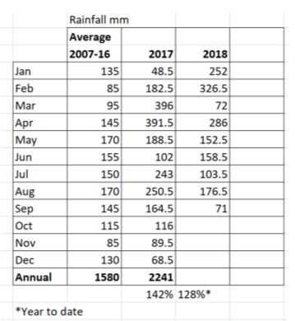

Fig 3 Monthly Rainfall Averages 2007-2016 and Monthly Totals January 2017 to September 2018

(Appendix 1 Fig 25)

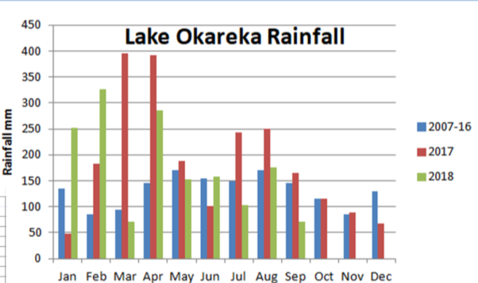

Fig 4 Monthly Rainfall Averages 2007-2016 and Monthly Totals January 2017 to September 2018

(Appendix 1 Fig 41)

In January 2017 rainfall was below average, February to April rainfall were significantly higher than average, May and June were average, July and August above average, November average December below average. The events in February to April created saturated ground conditions which meant that there was little storage capacity in the soil as the rainfall events continued.

This caused the lake level to rise very quickly in February - April 2017 and this continued through to September even though from 4th August to December 2nd the discharge was at 500L/s. This shows that there would have been more serious flooding if the discharge rate had remained at 239L/s during this period.

|  |
| --- |
|  |

Fig 5 Lake Level January 2017 to 1 November 2018 also showing Consent Maximum and Minimum Target Levels. (Appendix 1 Fig 23)

The summary below shows how quickly the lake level went from being close to the lower limit on 10 February 2017 to being 404mm above the maximum target limit on 17th April. The level was just above target range at the start of 2018 but events in January and February raised the level again. These results show the need to have the capacity to increase discharge rates above the 239L/s to address rainfall events, particularly cumulative events and considering the effects of climate change in the future.

|  |  |  |
| --- | --- | --- |
|  | **Lake Level** | **Comment** |
| Consent Target Range | 353.5m - 353.9m |  |
| 10 February 2017 | 353.531m | 31mm above target minimum |
| 13 March 2017 | 353.9m | At target maximum |
| 17 April 2017 | 354.30m | 404mm above target maximum |
| 03 September 2017 | 354.566m | 666mm above target maximum |

Fig 6 Lake Level in Relation to Consent Targets

Fig 7 shows the lake level in blue and the Waitangi Stream flow in red. The coloured line along the bottom shows the discharge rate from Lake Okareka with the frequency of discharge/pumping at different rates. Since December 2017 with potential to pump at 500L/s and rainfall 28% above average, the maximum pump rate operated for 7% of the time. This shows that the need to pump at the higher rates will be limited to cumulative significant events and that discharging at a maximum of 360L/s should be adequate for much of the time. The small elevation change between the lake and channel means that even with the pipe fully open which should convey flow of 360L/s, this can only occur when the lake level reached 353.94m or above due to lack of pressure. A spot check on 24th September 2018 showed the pipe capacity was 360L/s but the measured discharge rate was 269L/s with the lake level at the consent maximum target level of 353.9m. This naturally regulates the discharge rate with the lake level is within 'normal' range.

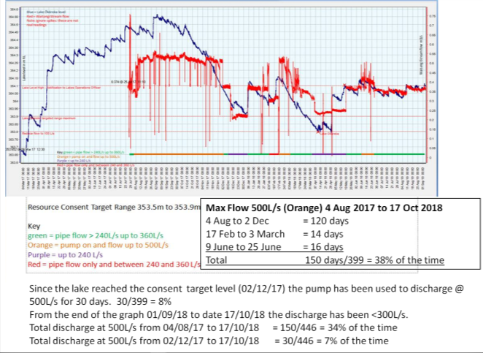

Fig 7 Lake Level (Blue), Stream Level (Red) and Discharger Rates Along the Bottom. (Appendix 1 Fig 24)

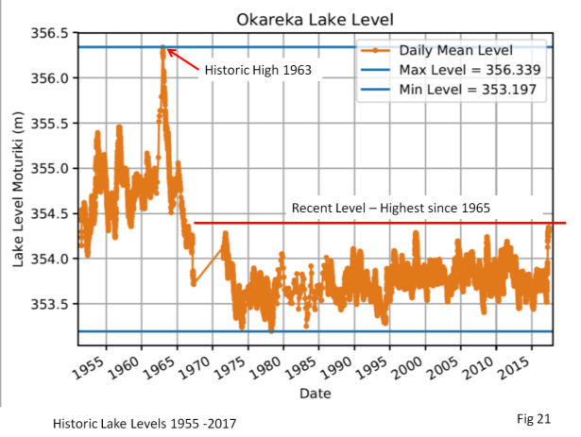

Fig 8 Historic Lake Levels (Appendix 1 Fig 21)

West (2017) showed that the rainfall in 2017 was statistically in excess of a 100 years event for durations of 1 to 50 days = 50 year event, 200 days to 250 days = 20 year event.

**5.0 Engineering Assessment**

Prior to increasing the discharge rate, an engineering assessment was made on the stream. Further assessments have been made as the discharge rate was increased.

**5.1 Engineering Works**

Increasing the flow rate to 500L/s has potential to increase down cutting of the stream bed and induce stream bank erosion. Initial investigation of the stream identified a number of existing areas of erosion, generally where vegetation debris had caused the stream flow to be diverted into the banks leading to subsequent erosion. The culvert under the 'right of way' was perched and this had created a plunge pool with woody debris causing bank and bed erosion. Sigma Engineering Consultants were engaged to undertake an assessment of the stream and identify where protection measures were required. These short term protection measures were implemented.

The assessment and completed works are detailed in Appendix 3 Engineering Works *'Lake Okareka Pipeline Engineering Comments for s92 Resource Consent Application CH17-00717'*  BOPRC November 2017; Niroy Sumeran.

The above works addressed the immediate erosion risk. A second Engineering assessment detailed permanent protection measures to be implemented. The design incorporated recommendations from ecologist Keith Hamill (Appendix 7 River Lake 26/10/17 and 25/09/18) and Eastern Region Fish and Game staff who have been extensively involved in discussions to ensure that the increased discharge does not impact on trout spawning habitat. Neighbours and iwi adjacent to the stream have also been consulted about the proposed works. These works are detailed in the following documents in Appendix 3 Engineering Works;

* *BOPRC Niroy Sumeran; Waitangi Stream* *Fisheries Work Summary September 2018.*
* *BOPRC Niroy Sumeran; Waitangi Stream Erosion Protection Location Works September 2018.*

**5.2 Monitoring**

The whole stream has also been inspected on a number of occasions. On completion of the short term protection works, the sites were inspected weekly for the first month then monthly and after large rainfall events. This same monitoring frequency will be employed during and after any future engineering works.

**6.0 Discharge Management Plan**

Resource Consent 60776 required a set of operating guidelines covering the day to day management and operation of the discharge structure. The current guidelines are attached in Appendix 3 Engineering Works (*Lake Okareka Outlet -Guidelines for Operation of Structure' August 2016).* The target lake level operating range specified in the current resource consent is 353.5m to 353.9m with a maximum discharge rate of 239L/s. The extreme weather conditions in March 2017 caused the lake level to rise well above the upper consent target of 353.9m. There were strong indications that discharging at the maximum consent rate of 239L/s would not be sufficient to bring the lake level back into the target range. For this reason, BOPRC invoked the provision of RMA s330 'Emergency works' to increase the discharge to a maximum of 500L/s. This consent application is to formalise the consent application details covered by the emergency consent into a long term consent covering discharge rates, stream maintenance and operational plan requirements.

As part of the investigation for the emergency works consent, two reports were prepared which validated and updated the water balance model and looked at how lake levels would respond to a range of discharge rates and rainfall event scenarios;

* *BOPRC Peter West Memo to A Bruere; 'Lake Okareka Modelling of Lake level Management Guideline Options'. 27 July 2018*
* *BOPRC Peter West Memo to A Bruere; 'Lake Okareka; Design of Pipeline Capacity, Impacts on Lake Level Management'. 17 November 2017*

The model included rainfall data up to May 2018 and included provision for climate change scenarios. The reports investigated discharge rates up to 600L/s and for a range of rainfall events up to 100 year AEP and various durations up to 500 days.

Although the model included flow rates up to 600L/s, the proposed maximum flow rate will be limited to 500L/s on the recommendations of the Engineering Consultant and Ecological Consultant.

From the modelling, two 'Operational Guidelines' are being considered.

Note that at this time these are indicative and are still being considered. It is suggested that the resource consent contains a condition requiring an approved 'Discharge Management Plan' but that this remains a live document, so it can be modified based on operational experience.

|  |  |  |  |
| --- | --- | --- | --- |
| Proposal 1 |  | Proposal 2 |  |
| Lake Level (up to) All Year | Pipeline Discharge L/s | Lake Level (up to) All Year | Pipeline Discharge L/s |
| 353.5 | 0 | 353.5 | 0 |
| 353.55 | 100 |  |  |
| 353.65 | 170 | 353.65 | 100 |
| 353.75 | 240 | 353.75 | 170 |
| 353.85 | 300 | 353.85 | 290 |
| 353.95 | 380 | 353.95 | 380 |
| 354.05 | 460 | 354.05 | 460 |
| 400 | 500 | 400 | 500 |

Fig 8 Operational Guidelines - Indicative

The following is a summary from West 27/07/18

Table 4 shows the % of time above and below target levels for two time sequences June 1991 to May 2018 and February 2017 to May 2018. The latter time sequence is important as it includes the outcomes resulting from a series of significant rainfall events. The % time above target limit was 29% and 32% respectively for the two proposed guidelines compared with 91% under the existing guidelines. Also important are the maximum lake levels under the different regimes;

Maximum Observed Level* 354.56m (0.66m above target maximum)

Existing Guidelines** 355.03m (1.13m above target maximum.)

Proposed Guideline 1 354.11m (0.21m above target maximum)

Proposed Guideline 2 354.13m (0.23m above target maximum)

* After emergency works intervention

** Without intervention

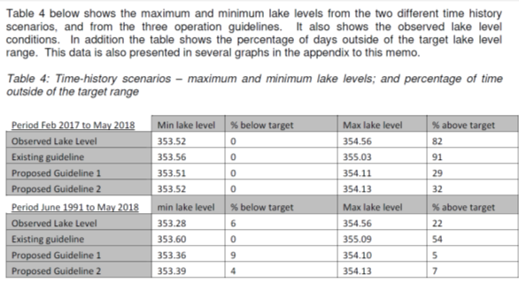

Fig 9 Table 4 Time-History Scenarios

In Table 5, the Feb 17 -May 18 event scenarios show the % time flowing above 400L/s was 37.5% and 40.4% respectively. This indicates that even in extreme events the maximum discharge rate of 500L/s occurs for just a small proportion of the time. The proposed guidelines should maintain minimum flow of 100L/s.

Using the longer timeframe rainfall data June 91-May 18 the % time flowing above 400L/s is 9.8% and 14.5% respectively. This shows that over the longer timeframe the maximum discharge rate of 500L/s will occurs for a small proportion of the time with flows of <100L/s for less than 10% of the time.

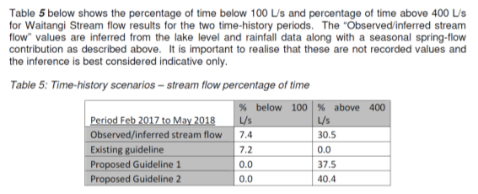

|  |
| --- |
|  |

Fig 10 Table 5

Table 6 and 7 (Fig 11) show that under the proposed guidelines there are fewer days with flows <100L/s but the longest period with zero flow is much higher under the proposed guidelines than the existing.

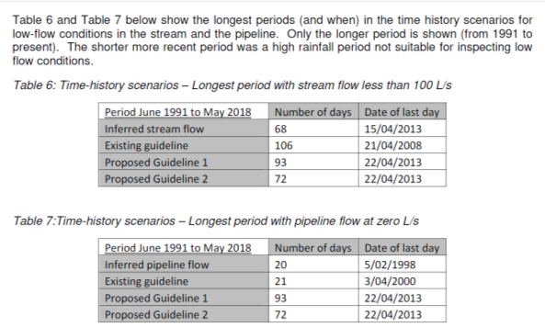

Fig 11 Tables 6 and 7

Table 8 shows that under the existing guidelines there is a significant risk to property in a 1% AEP event through all climate scenarios but under the proposed guidelines this is eliminated in most scenarios and where not eliminated reduces to orange risk (building freeboard level) rather than floor level of the lowest building. Discussions on minimum flow are ongoing with Fish and Game. It may be prudent in some situations to reduce flow below 1900L/s to maintain flow for longer periods. For this reason, the Operational Guidelines should remain a live document with flexibility to response to situations.

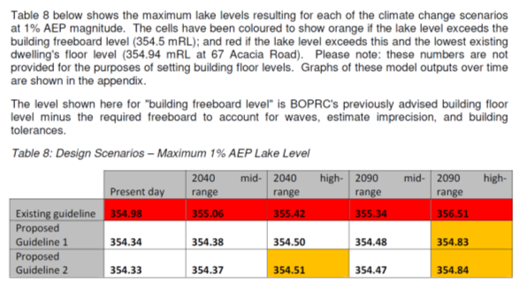

Fig 12 Table 8 maximum Lake Levels Under 3 Scenarios

Note Table 4 and 5 are based on actual rainfall data, Table 8 is based on 100 year model.

The above are paraphrased from the reports, it is recommended that both reports are read fully for an understanding of the work and implications of the different discharge regimes.

**7.0 Assessment of Environmental Effects**

The proposed increase in maximum lake discharge rates up to 500L/s will have a number of positive environmental benefits.

In September 2017, the lake level was at its highest since 1963. There was a risk to property if the lake level remained high or increases. At this time two public access footpaths - the Okareka board walk and the Boyes Beach camp site path were partly submerged and there was clear damage to the newly constructed campsite path. There is also damage to the lake shore and retention structures. Most of the lake jetties were under water including the jetty adjacent to the only public boat ramp on the lake.

The effects of climate change mean that large rainfall events are likely to be more frequent and of larger scale. Recent modelling (including the 2017 rainfall events) indicates that a maximum discharge rate of 239L/s is unlikely to prevent flooding of property during future rainfall events. Increasing the maximum discharge rate will allow better control in the build up, during and after rainfall events. The protection of natural and physical resources along with the social, cultural and economic wellbeing of people are considerations under the Resource Management Act.

**7.1 Water Quality**

There are seven lakes that discharge directly or indirectly into Lake Tarawera or via groundwater flows (Okareka, Tikitapu, Rotokakahi, Okataina, Rotomahana, Okaro and Rerewhakaaitu). As the receiving environment for Lake Okareka, there is potential for the water quality in the Waitangi Stream and Lake Tarawera to be affected by the water quality from Lake Okareka. The flow from Lake Okareka already discharges into Lake Tarawera. This consent is only to increase the rate of flow when lake levels rise. Historically Lake Okareka water quality was lower than Lake Tarawera, but the introduction of reticulated sewage has helped to improve Lake Okareka. A further consideration of the effects of Lake Okareka water quality is that it forms only 12.9% of the wider Tarawera catchment (See Fig 13 and Appendix 1 Fig 42).



Fig 13 Lake Tarawera Catchment

The primary tool used by BOPRC to assess and report on lake water quality is the Trophic Level Index (TLI). This index combines individual trophic level values assigned to concentrations of chlorophyll 'a', total phosphorus, total nitrogen, and transparency assessed by Secchi disk depth (Burns et al. 1999).

The following extract is from *BOPRC; Trophic Level Index Summary Scholes Sept 18;*

***Lake Okareka-*** *Annual average TLI increased from 3.2 last year to 3.5 for 2017/2018. The three year annual average was 3.4 TLI units. The increase in the last two years has been primarily due to increases in chlorophyll-a and TP. TN decreased on average compared to last year. Hypolimnetic oxygen levels did improve on the last two years, with a slower rate of oxygen consumption over the stratification period. Ammoniacal-nitrogen concentrations did increase in the hypolimnion over the stratification period, although dissolved reactive phosphorus and nitrate-nitrite-nitrogen did not. A dramatic increase in lake level over the year will have had some influence on nutrient concentrations, particularly an increase in particulate phosphorus.*

***Lake Tarawera -****The annual average TLI in Lake Tarawera remained the same as 2016/2017 at 3.1. The TLI remains almost 0.5 above the RNRP objective of 2.6, with the three year average at 3.1.*

*Like many of the other lakes, the chlorophyll-a annual average concentration increased compared to the previous nine years, with a corresponding decrease in water clarity. Both total and dissolved phosphorus concentrations decreased moderately compared to last year’s annual average. Annual average nitrogen concentrations were similar to last year, with nitrate-nitrite-nitrogen showing an increase in both the epilimnion and hypolimnion. The annual average Secchi depth (water clarity) has increased compared to the previous five years.*

*Cyanobacteria biovolumes for the most part did not reach alert levels, with the exception of one sample taken near the Tarawera outlet (Te Tapahoro) which did reach the orange alert level in early February. No health warnings were posted over the 2017/2018 season.*

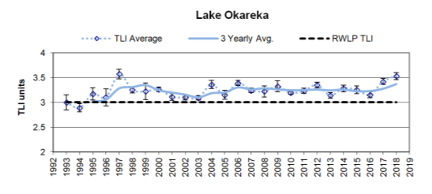

Fig 13 Lake Okareka Annual Average and Three year Average TLI Results (Appendix 1 Fig 30)

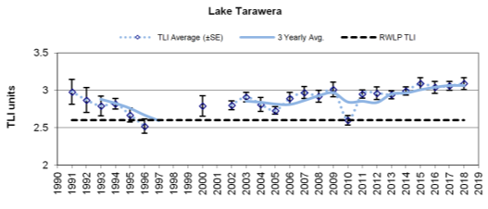

Fig 14 Lake Tarawera Annual Average and Three year Average TLI Results (Appendix 1 Fig 30)

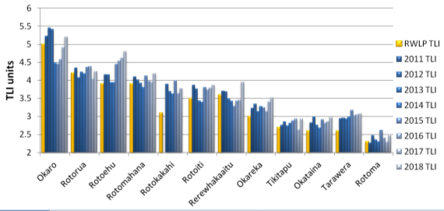

Fig 15 Regional Natural Resources Plan TLI Objectives and Annual TLI Results 2011 to 2018

(Appendix 1 Fig 30)

Water samples from both lakes were collected on 18 September 2018 and 29 October 2018. The latter set were collected after a rainfall event. See Appendix 5 Water Quality Analysis

All the sample parameters are very similar except for;

Electrical Conductivity in Tarawera 7-11 times higher than Okareka - EC is a measure of dissolved salts in the water.  As the Tarawera measurement was at Rangiuru Bay which has a car park and boat ramp nearby this could explain the difference, with sediment discharging from the ramp and adjacent road and parking area.

E. coli levels were higher in Tarawera in the first sample (38 MPN/100ml in Tarawera compared to 3.1 MPN/100ml at the Okareka outlet), but higher in Okareka in the second sample (7.3 MPN/100ml in Tarawera compared to 17 MPN/100ml at the Okareka outlet). This change around may have been due to the heavy rainfall. Although the range in results from 3.1 to 38 looks quite large, the green surveillance limit for swimming sites is 260 units, so E.coli results at both locations are well within swimming limits -details below.

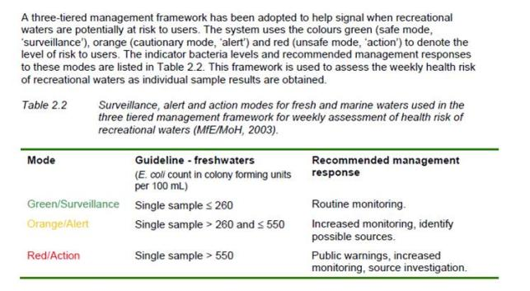

Fig 16 Extract from 'Recreational Waters Surveillance Report' BOPRC Publication 2018/03

Relative water qualities have also been assessed in the following Ecological assessment; *River Lake Ltd Keith Hamill; Lake Okareka Overflow, Waitangi Stream; Ecology Effects of Increased Flow 26 October 2017'* which in summary states:

***Water quality of discharge compared to Waitangi Stream baseflow***

*No water quality information is available to compare the Waitangi Stream at its source with the Waitangi Stream after it has been augmented with Lake Ōkāreka outlet water. Almost all the water in the Waitangi Stream comes from the Lake Ōkāreka outlet pipe, and the baseflow in the Waitangi Stream is estimated to be only 5 L/s and 30 L/s in summer and winter respectively. The Waitangi Stream channel has adjusted over many years to having outlet water from Lake Ōkāreka.*

*The additional water from Lake Ōkāreka outlet over and above the consented flow of 239 L/s will have negligible effect on water quality in the Waitangi Stream because the Waitangi Stream flow is already dominated by the outlet water. However, erosion caused by the increase in stream flow may reduce water clarity downstream.*

***TLI results of Lake Ōkāreka and effect on Waitangi Stream and Lake Tarawera***

*Lake Tarawera has historically been classed as oligotrophic, but water quality has been deteriorating over the last 20 years and the most recent water quality results class the lake as ‘mesotrophic’. The trophic level index (TLI) is 3.1. The deterioration is driven by an increasing trend in nitrogen and phosphorus. The concentration of phosphorus (P) in Lake Tarawera is relatively high compared to nitrogen (TN:TP ratio = 5.2), and the increasing trend in P has been particularly strong (i.e. increasing by 7.2% per year from 2002-2014) (Hamill and Scholes 2015). The high P concentration is probably influenced by geothermal inputs.*

*Lake Ōkāreka is classed as mesotrophic but has slightly worse overall water quality compared to Lake Tarawera (TLI score of 3.4 compared to 3.1 for Lake Tarawera) (Table 1). The TLI score of Lake Ōkāreka has been relatively stable (no trend) over the long term (Hamill and Scholes 2017). Compared with Lake Tarawera, Lake Ōkāreka has higher concentrations of nitrogen and lower concentrations of phosphorus. Water clarity, temperature and pH are similar (Table 2).*

*The increase in flow from Lake Ōkāreka to Lake Tarawera via the Waitangi Stream will increase the concentration of nitrogen but dilute the concentration of phosphorus in Lake Tarawera. The overall effect of the change in flow on the water quality of Lake Tarawera is expected to be undetectable.*

From the above data, water quality within the two lakes is very similar so Lake Tarawera is unlikely to be adversely affected by the increased flow from Lake Okareka.

Hamill (Appendix 7) comments on water quality;

*It is unlikely that there are any unwanted organisms in Lake Ōkāreka that are not already in Lake Tarawera because the lakes have been connected for many years.*

**7.2 Additional Water Take and Discharge Structures**

The current water take is an engineered structure where the outlet canal discharges into a pipe. The pipe intake is protected by headwalls and a 100mm metal debris screen (Appendix 1 Fig 11). This will not alter. The increased flow from 239L/s to 360L/s through the pipe will be achieved by opening the gate valve within the pipe. This will not affect the current intake. It should be noted that even with the valve fully open, flow of 360L/s will only occur when there is sufficient pressure head. This will only be achieved when the lake level exceeds the current consent upper target level of 353.9m

The additional pipe intake removes water from just below the debris screen and immediately above the discharge pipe intake. The pump sits above the channel and the additional discharge (up to 140L/s) is pumped via surface pipe to discharge at the current dissipater site. The installation caused minimal ground and vegetation disturbance. See Appendix 1 Figs 12-14.

The current pipe discharges into a concrete trough energy dissipater which reduces some of the energy from the flowing water (Appendix 1 Fig 15). It then cascades over large riprap to dissipate more energy before flowing into the Waitangi Stream. The second pipe discharges adjacent to the dissipater. Addition rock armouring has been placed to ensure that the increased discharge does not create erosion.

The discharge site has been monitored and there is no evidence of erosion. This will be monitored routinely and when discharge rates are ramped up.

Although there will at times be an increase in water volume discharge through both the existing pipe and the additional pipe, this is not anticipated to lead to an increase in adverse effects.

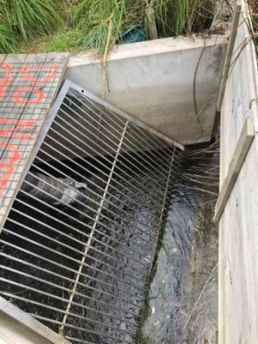

Fig 18 Mesh debris screen above culvert intake. Second pipe just visible (Appendix 1 Fig 11)

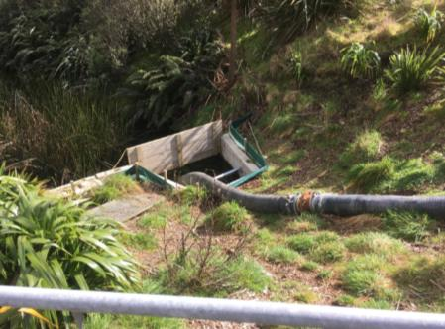

Fig 19 Pumped water take off downstream of the mesh screen and above the original discharge pipe (Appendix 1 Fig 11)

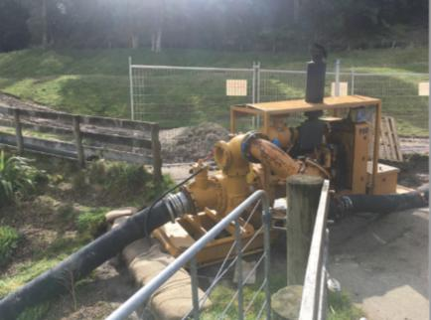

Fig 20 Pump in the second pipe system (Appendix 1 Fig 12)

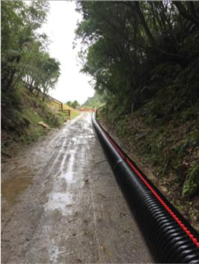

Fig 21 Additional second pipe (Appendix 1 Fig 12)

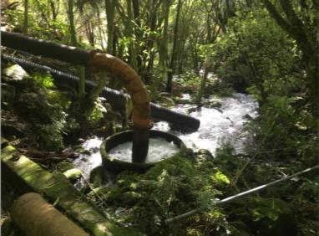

Fig 22 Original dissipater with second pipe in the background (Appendix 1 Fig 15)

**7.3 Additional Flow -Physical Effects on Waitangi Steam and Downstream**

As part of the emergency works resource consent application, Reports by Pattle Delamore 2017 and River Lake (2017 and 2018) identified potential and actual erosion risk in the Waitangi Stream. Areas of existing erosion were identified before the discharge rate was increased. Engineering assessments are covered in Section 5.1 and associated engineering reports in Appendix 3.

Short term remedial works have been completed and the design for permanent protection works have been circulated and approved by the consultant ecologist, Fish and Game and other affected parties. These include use of rock rip-rap gabion baskets and large boulders as well as some in-stream structures to aid fish passage. After discussion with Fish and Game, it was agreed that these works will be completed in January to avoid adverse effects on fisheries values.

Further details about the permanent protection works and mitigation measures to avoid erosion and sediment discharge during the works are detailed in report 'Waitangi Stream Erosion Protection Location Works' September 2018 Sumeran BOPRC.

As with most stream mouths, there is a small delta where the stream enters Lake Tarawera. There is finer material covered by a coarser sandy layer. It is likely that the finer sediments were deposited before the flow was increased. This layer is quite firm. The upper coarser material is likely to have been deposited when the flow was increased, and the increased velocity could carry larger particle sized material. This layer is unconsolidated and is likely to be moved by lake currents.

The recent increase in discharge will have mobilised bed material. As this has now stabilised it is likely that future increases in the flow discharge rate will not generate as much sediment. It should also be noted from the flow modelling that flows in excess on 400L/s will only occur for approximately 10-15% of the time.

It is anticipated that the adverse effects of the engineering works will be short term, have minimal impact and be undertaken at an appropriate time of year to avoid critical spawning periods.

**7.4 Culverts**

There are three culverts in the stream between the dissipater and Lake Tarawera. See Appendix 3 These are;

* Spencer Road - The culvert has a diameter of 1150mm. RLC and BOPRC Engineering staff have confirmed that the pipe is more than adequately sized to convey a pipe discharge of 500L/s. It should be noted that in the 1960's base flow from the spring was estimated to be 400L/s. During the high flow discharge at 500L/s, the culverts were monitored and were flowing al less than 50% capacity.
* 341 Spencer Road Right of Way - This culvert is located approximately 140m downstream of the Spencer Road culvert and also has a diameter of 1150mm. This pipe is also deemed to be more than adequately sized to convey a pipe discharge of 500L/s. Immediately below the culvert is an area of erosion which has been described in the engineering section of this report. Some additional protection at the culvert outlet is proposed. This will be undertaken in after consultation with adjacent landowners.
* There is a 900mm diameter culvert on a private property close to the lake. Under the flow regime of 360L/s this pipe was running at close to full capacity because it was partially closed off and, in that configuration, would not be able to convey the additional flow generated at between 360 and 500L/s discharge. River Lake Ltd in their report of 26 October 2017 noted that the trout had navigated through the culvert but the flow rate was a barrier to fish passage and recommended removal of the obstruction. After consultation between BOPRC, Fish & Game and the owner, the restriction was removed an additional 450mm overflow pipe was installed. This is at an elevated level and only comes into use during high level flows.

Culvert maintenance works are detailed in report 'Waitangi Stream Erosion Protection Location Works' September 2018 Sumeran BOPRC.

**7.5 Fish and Macro-invertebrates**

Increasing the flow can have an adverse effect on in-stream habitat and ecological values by erosion, sediment deposition, removal of habitat and increase in the flow rate restricting fish movement. This could affect the quality of trout spawning areas.

The Waitangi Stream is listed in Schedule 1A of the Bay of Plenty Regional Water and Land Plan *'Important Habitats of Trout' - Regionally significant habitat and fisheries values.* There has been consultation with Eastern Region Fish and Game (ERFG) and the landowner to address potential adverse effects on the fishery. ERFG have been actively involved in the proposed engineering design and habitat protection works as well as looking at the flow regime and particularly how changes in the flow rate are implemented.

Proposed mitigation includes;

* Erosion protection in vulnerable areas upstream of and within the spawning area
* Create low energy areas (e.g. J hooks) where fish can rest during times of high flow
* Open or close the valve incrementally and monitor to prevent sudden changes in flow. The rate will be agreed with Fish and Game.

ERFG has provided written support of the measures to reduce the water level in Lake Okareka and the protection measure in the Waitangi Stream. The timing of in-stream works has been agreed with ERFG to minimise the potential impact on trout spawning.

BOPRC will continue to work with ERFG and the land owner to ensure protection of this valuable fishery habitat.

The wider ecological values in the Waitangi Stream, and potential effects of increasing the flow up to 500L/s are addressed in the two ecological reports;

* River Lake Ltd Keith Hamill; Lake Okareka Overflow, Waitangi Stream; Ecology Effects of Increased Flow 26 October 2017
* River Lake Ltd Keith Hamill; Lake Okareka Overflow, Waitangi Stream; Ecology Effects of Increased Flow 25 September 2018

The first report is an assessment of the stream and recommendations for protection. The second report is an update and considers the engineering design and implementation methods.

The report concludes;

*Increasing the flow of the Waitangi Stream to 500 L/s has caused erosion of the stream bed between Culvert 2 and the waterfall. This has removed what is likely to have been high qualtiy habitat for aquatic macroinvertebrtes. The stream habitat above the waterfall has potential to support fish species with the ability to climb, but the increase in water velocity is likely to be restricting fish passage through the existing culverts. Some of the exiting culvert may have been fish barriers even before the increase in stream flow. Recommendations are made on how to mitigate these effects in the long term.*

The recommendations to improve fish passage have been incorporated into the engineering design.

The key mitigation measures are;

* Manage the discharge rate based on lake level and weather predictions to increase and decrease flow rates gradually to minimise the duration of high flow discharge.
* Open the valve incrementally and monitor downstream. If any effects are observed, they are managed.
* Downstream monitoring will consist of visual inspections at the start and at regular intervals when the valve is operating above 360L/s. In the first week there will be daily inspection. Monitoring will include making a photographic record at key points.
* The BOPRC Environmental Data Services department (EDS) will gauge the stream at times during this period to calibrate the valve settings at these flows.
* As the lake level falls, the discharge rate will be managed the ensure that the discharge rate is the minimum required to ensure continuous fall in lake level to optimum levels. At the same time, weather forecasts will be closely observed to ensure the lake has capacity to contain a major rainfall event and retain the lake level within normal management limits. It should be noted that the pipes may not flow at the controlled rate unless lake levels are high due to lack of head pressure. e.g. With a pipe capacity of 360L/s the discharge rate cannot physically exceed 300L/s until the lake level reaches approximately 354.9m which is the current consent target maximum.  This provided additional restriction of the time that the discharge will be at higher rates.
* Minimal flow rates will be managed in conjunction with Fish and Game, but if the lake level falls below the outlet the minimum target flow rates will not be achievable. Management will include restricting the flow to minimum levels as lake levels fall towards the lower target level.
* BOPRC will also notify the Lake Okareka community, Fish and Game, iwi and downstream land owner when valve settings are changed.

**7.6 Minimum Flow Rates**

The Lake Okareka control pipeline has been discharging into the Waitangi Stream since 1965. The natural base flow of the Waitangi Stream has previously been estimated to be around 100 litres/second but River Lake (16/10/17) estimate the flow to be much lower (5L/s in summer and 30L/s in winter). The 2001 resource consent contained the following clause;

6.2 *The consent holder shall ensure that a minimum rate of discharge of 100 litres per second is maintained as far as practicable, to contribute to the base flow of the Waitangi Stream.*

*While the figure of 100 litres per second as a minimum discharge limit appears to be reasonable, there are practical problems in achieving this figure. Firstly, the control over the gate valve does not appear to be sufficiently sensitive to achieve a flow of 100 litres/second. Secondly, if the level in Lake Okareka drops to below the invert level of the pipeline intake, then no flow will occur through the pipeline. Thirdly, there will be times when the valve in the pipeline may need to be closed completely (such as for maintenance, or if there is a threat of an unwanted species in Lake Okareka). Notwithstanding these potential problems, the matter of setting a minimum discharge flow (as far as practicable) is appropriate.*

From the low spring flow noted by River Lake, and the small catchment area between the lake outfall and the lower Waitangi fish spawning site, it follows that most off the flow in the Waitangi Stream comes from the Lake Okareka outfall.

West (27/07/18) Table 5 lists % flow below 100L/s as;

Existing Guidelines 8.8%

Proposed Guideline 1 9.6%

Proposed Guideline 2 4.1%

The proposed guidelines are equal to or better than the current system, but if lake levels fall below the pipe invert it will result in zero flow out of the lake.

7.7 Potential for Transfer of Pests from Lake Okareka to Lake Tarawera via the Pipeline Control System.

The question of potential pest transfer from Lake Okareka to Lake Tarawera has been addressed in River Lake 26/10/17.

Questions have been raised about the intake screen design and mesh size and its effectiveness in reducing the transfer of unwanted organisms into Lake Tarawera. The outlet from Lake Ōkāreka has a screen size of about 100mm. This will screen debris but will not stop the transfer of organisms between Lake Ōkāreka and Lake Tarawera. However, it is unlikely that there are any unwanted organisms in Lake Ōkāreka that are not already in Lake Tarawera because the lakes have been connected for many years. The higher flow rates will have negligible difference on the transfer of organisms between the lakes because even at 500 L/s there was low water velocities in the outlet channel upstream of the intakes.

Common aquatic plant pests of *Elodea canadensis*, *Lagarosiphon major*, *Egeria densa* and *Ceratophyllum demersum* (hornwort) are present in both Lake Ōkāreka and Lake Tarawera.

**7.8 Recreation**

The lake discharge system, pipes dissipater and Waitangi Stream are all located on private property with no public access.

**7.9 Visual Impact**

The only visual effect of the proposed activities is the location of the second pipe on the lake access track, and protection works downstream of the 'right of way' culvert. Both of these locations are on private property and written approval of affected parties has been received.

**7.10 Summary of Environmental Effects**

The effects discussed above relate to the taking, diversion and discharge of and increased volume of water passing through the existing pipeline. It is evident that the pipeline provides benefits in terms of lake level control within Lake Okareka, but recent events show that it cannot meet the discharge levels from current and anticipated rainfall events. It is considered that the potential adverse effects of the activity can be avoided, remedied or mitigated by the methods proposed in this application.

**8.0 Cultural Values**

Lake Okareka is within the Rohe of Tuhourangi Tribal Authority. Lake Tarawera is within the rohe of Ngati Rangitihi. Prior to lodgement of the resource consent variation in July 2017 a site meeting was undertaken with Alan Skipwith (Chair-Tuhourangi Tribal Authority) and Ken Raureti (Chair - Ngati Rangitihi). At that meeting and subsequent discussions, concerns which had been raised and documented in 2011 consent application were reiterated.

A number of meetings have taken place with Alan Skipwith (Chairman Tuhourangi Tribal Authority) and latterly the authorities recently appointed Environmental Manage Roku Mihinui. Alan is also a member of the Working Party and Ken has been invited and receives minutes.

Alan reiterated their concerns which had been expressed in the 2001 application namely the cultural offensiveness of mixing waters from two different water bodies (each with their own mauri) is a very real concern to Tangata Whenua. They would like to see outflow controls removed and the lake be allowed to fluctuate within its natural levels. However, he acknowledged that there are houses around the lake and he would like to see the lake level managed within an acceptable range to protect property including iwi land fisheries values and the outlet into Lake Tarawera (Okareka Working Group Minutes 4 April 2018). A site meeting took place 18th September 29018 to look at the whole discharge system and proposed protection works. This was followed by a site meeting with Roku Mihinui 24th October 2018 (Alan was unable to attend) when the stream section flowing through the Ohorongo Block was walked. Roku then reviewed the proposed increase in discharge up to 500L/s and the proposed engineering works and provided Tuhourangi written support to the proposal in an Email dated 29 October 2018 (Appendix 4).

A copy of this 'Long Term' resource consent application has been sent to Tuhourangi Tribal Authority and Ngati Rangitihi for review.

Te Arawa Lakes Trust are part of the Lake Okareka Working Party and Environment Manager Nicki Douglas attended the above site inspection on 18th September 2018. Nicki provided written support but made clear that this was only for the emergency works consent (Email Appendix 4). A copy of this 'Long Term' resource consent application has been sent to TALT for comment.

An Archaeological Assessment around the Waitangi Stream area was undertaken by Insitu Heritage. This report concluded that it was '*highly* *unlikely to affect intact archaeological sites'.* See Report; Insitu Heritage Archaeological Assessment Waitangi Stream 25 October 2018 (Appendix 8).

**9.0 Consultation and Information Distribution**

NB This section to be updated. In addition to the consultation listed below, a copy of the draft long term consent application has been provided to affected parties for comment. Responses will be added to the application for submission.

On 23 June 2017 BOPRC made an application under s330 of the Resource Management Act (Emergency works and power to take preventive or remedial action) to vary the current resource consent (RC 60776) to allow the discharge valve to be opened to its maximum physical capacity of 360L/s, to install a second pipe and pump to allow discharge of up to 500L/s and to undertake erosion control works within the Waitangi Stream.

A requirement of invoking s330 is that a resource consent application must be lodged within 20 working days of the s330 application. Limited consultation was undertaken in the 20 day period from provision on 23 June 2017 and lodgement of the consent variation on 21 July 2017. This included affected residents, community groups, iwi, Te Arawa Lakes Trust, Fish & Game, Rotorua Lakes Council.

From the pre-lodgement discussion, it was clear that there were wider issues around the management of the lake level and discharge via the Waitangi Stream. It was decided that following full consultation with affected parties, a second resource consent application was to be made for the long term control of the lake level and a working party was established to consider the proposed changes to control measures. This application incorporates outcomes from the Working Party meetings and discussions. A copy of the application was made available to all members of the Working Party for comment.

Appendix 4 contains meeting attendance sheets minutes from the meeting along with associated documents. In the 16 months since the variation application consultation has been ongoing with the Working Party as a group and with some members individually where they have special interest (e.g. iwi, TALT, Fish and Game).

**9.1 Consultation Objectives**

* To clearly identify affected parties.
* To inform affected parties of the current level of the lake and what actions are being undertaken.
* To ensure that cultural values are identified respected and upheld.
* To identify and listen to the views, concerns and aspirations of the working party representatives
* To answer questions and provide information to assist the working party to make informed decisions about the long term management of the water level in Lake Okareka.
* As far as possible reach a consensus view on the management of lake levels that will address concerns of Lake Okareka residents, ensure that any effects of high flow discharge on the Waitangi Stream are no more than minor, that properties adjacent to the Waitangi Stream are not affected by the increased discharge and there are no adverse effects on Lake Tarawera.

**9.2 Parties Consulted**

* Work updates emailed to residents and also listed on the BOPRC website (25 Updates)
* Affected parties adjacent to Waitangi Stream
* Tuhourangi Tribal Authority*
* Te Arawa Lakes Trust*
* Lake Okareka Community Association*
* Lake Tarawera Ratepayers Association *
* Eastern Region Fish and Game*
* Rotorua Lakes Council*
* Tarawera Lakes Protection Society*
* Department of Conservation
* Lake Okareka Working Party

*Include Members who also sit on the Lake Okareka Working Party

9.2.1 Emailed updates to residents and on BOPRC website

BOPRC created a portal on the BOPRC website containing information of the lake level and actions being taken. It provided 25 updates in the period July 2017 to October 2018. These were emailed out to residents and any other interested party on request. The updates include details of access to the website portal which contains all the updates, and extensive direct email list. There are also extracts and links on the Lake Okareka Community Association (LOCA) Newsletter and on the LOCA Website. Appendix 1 Figs 35 and 36 are examples of one of the updates (Lake Okareka Pipeline Update #12. August 2017) and extract from the LOCA website.

Note that a number of LOCA members and Lake Okareka residents are on the Working Party, including LOCA Chairman Martyn Norrie.

9.2.2 Affected Parties Adjacent to Waitangi Stream

Before the discharge rate was increased, engineering inspections were undertaken throughout the length of the Waitangi Stream. This identified areas of erosion that currently required remedial intervention as well as areas that could be at risk if the flow rate was increased. An ecological investigation also looked at potential erosion risk and proposed mitigation measures. From these two investigations, engineering plans were drawn up for short term measures to be implemented (e.g. shuttering and bed protection south of the right of way culvert). These were prepared in full consultation with adjacent neighbours. Long term/permanent protection plans have also been drawn up and discussed with affected neighbours. The responses received show support for the protection measures and proposal to monitor the stream in future and undertake additional works as and where necessary. Appendix 3 contains the Engineering details that were send out and received responses where.

9.2.3 Tuhourangi Tribal Authority

Tuhourangi Tribal Authority have mana whenua interest over Lake Okareka and Tarawera. A number of meetings have taken place with Alan Skipwith (Chairman Tuhourangi Tribal Authority) and latterly the authorities recently appointed Environmental Manage Roku Mihinui.

Cultural values are discussed in Section 8. In addition to the working party meetings, a site meeting took place 18th September 29018 to look at the whole discharge system and proposed protection works. This was followed by a second site meeting with Roku Mihinui 24th October 2018 (Alan was unable to attend) when the stream section flowing through the Ohorongo Block was walked. Roku then reviewed the proposed increase in discharge up to 500L/s and the proposed engineering works and provide Tuhourangi written support to the proposal on 29 October 2018. See Appendix 4 Consultation.

Note that Alan is also a member of the Working Party.

9.2.4 Ngati Rangitihi

Ngati Rangitihi have mana whenua interest over Lake Tarawera. There was a site meeting and initial discussions with representative Ken Raureti and Tuhourangi Tribal Authority Chairman Alan Skipwith in July 2017. Ken was invited to sit on the working party. All minutes have been sent and a copy of this consent application has been sent to Ngati Rangitihi Environment Officer Chris Clarke for comment.

9.2.5 Te Arawa Lakes Trust

There have been various communications with the Te Arawa Lakes Trust (TALT) about the Lake Okareka Discharge Consent. On 18 September 2018 Environment Manager Nicki Douglas attended a site meeting with Tuhourangi Tribal Authority representatives and chairperson of the Ohorongo Block trust (Karen Walmsley) along with BOPRC staff. Nicki provided an email of support for the emergency consent (19 September 2018) but reserves the right to provide comment on the long term consent after reviewing the application. She also deferred to Tuhourangi Tribal Authority and iwi land owners on the in-stream works. Note that TALT representatives are also members of the working party.

9.2.6 Lake Okareka Community Association

Not surprisingly many members of the Lake Okareka community are concerned about the high lake level and the adverse effect on property -houses, jetties, gardens and lake margin protection. Other facilities such as the Okareka boardwalk and the Boyes Beach - DOC campground walk way have been adversely affected by the high levels. There have been a number of community meetings and circulars which have been distributed by Lake Okareka Community Association (LOCA) with updated information placed on their website.

Andy Bruere (BOPRC) has made a number of presentations to LOCA and there has been ongoing provision of information via the email updates (See 9.2.1). The group has provided written support for the emergency works consent and a copy of this long term consent application has been provided for comment. The main forum for consultation has been via the Working Party. A number of members of LOCA are also part of the working party, including Chairman Martyn Norrie.

9.2.7 Lake Tarawera Ratepayers Association

Andy Bruere (BOPRC) has made presentations to the Lake Tarawera Ratepayers Association and there has been ongoing provision of information via the email updates (See 9.2.1). Andy has also met with Chairperson Libby Fletcher and the group has provided written support for the emergency works consent and a copy of this long term consent application has been provided for comment. The main forum for consultation has been via the Working Party. A number of members of LTRA are members of the working group including chairperson Libby Fletcher.

9.2.8 Eastern Region Fish and Game

There has been ongoing discussion with Fish and Game since June 2017 about protection of the trout fishery and proposed erosion protection works. The final design is a collaboration between the consultant ecologist, Fish and Game and BOPRC. The proposed timing of works in the fish spawning area has been agreed with Fish and Game who have provided written support for the emergency works consent. Communication about the discharge rates particularly in relation to ramping rates and management during low flows will be ongoing with Fish and Game.

9.2.9 Rotorua Lakes Council

Rotorua Lakes Council have provided support and information on building levels, flood risk etc. They have provided written support for the for the emergency works consent and a copy of this long term consent application has been provided for comment. Staff from RLC are members of the Working Party.

9.2.10 Tarawera Lakes Protection Society

The President of Tarawera Lakes Protection Society has provided the following response;

*We have had a discussion amongst our members and it is looking like we might need to get some legal advice since what is now proposed appears to be a blatant misuse of the emergency proceedings section of the RMA.*

*There is no longer any emergency. The emergency consent needs to be revoked and consultation continue with drafting a new possible change/ variation to the existing consent to allow for greater outflow volume.*

*Please advise ASAP whether this is the approach council will take. If not we will need to lodge for a judicial review.*

*Our Society will confirm any action likely once we have heard back from you.*

*PS We also has a Lake Tarawera Ratepayers Association meeting last Sunday and the committee is also not happy with continued increased outflow from Okareka to Tarawera. They have asked me to draft a proposed response to you from LTRA according. That should be forthcoming also once I have had a response from you.*

BOPRC responded that the use of s330 is appropriate. There has been no further communication from TLPS. Note that the President Fred Stevens and one other member sit on the Working Party.

Re the reference above to Lake Tarawera Ratepayers Association, it should be noted that Libby Fletcher (Chairperson Lake Tarawera Ratepayers Association) in her email of 14 August 2018 wrote;

*...'Please take that as the view of the Tarawera Lakes Protection Society only it is not the view of the lake Tarawera Ratepayers Association'.*

9.2.11 Department of Conservation

The Department of Conservation were consulted and provided written response that they are an 'Interested' rather than 'Affected’ party and provided their written support to the s330 emergency Works provision -Email 20 July 2017. See Appendix 4 Consultation.

9.2.12 Lake Okareka Working Party

The minimal consultation in the 20 days between the s330 Emergency Works being invoked and the consent having to be lodged identified that there were a number of concerns from different groups within the community and it was decided that a working party should be established to bring everyone together to work through the issues and develop group objectives in developing a long term consent for the management of lake levels.

The Working Party has met on three occasions; 30 November 2017, 4 April 2018 and 21 August 2018. Minutes attached in Appendix 4 Consultation. The members were asked to list their expectations for the group. The key outcomes were; To manage the level of Lake Okareka to;

* Protect Lake Okareka houses, property and infrastructure from high water levels;
* Recognise and protect cultural values in the lakes and Waitangi Stream
* Protect houses, property and infrastructure adjacent to the Waitangi Stream for potential adverse effects resulting from elevated flow rates.
* Ensure that higher levels of discharge do not adversely impact the fishery and in-stream ecological values of Waitangi Stream.
* Ensure that increased lake discharge rates do not lead to accelerated erosion of the Waitangi Stream bed and banks.
* Ensure that water quality in lake Tarawera is not adversely affected by increased discharge rates.
* Develop the infrastructure and lake level management plan that has the technical capacity to maintain lake levels within an agreed range as far as practicable.

**9.3 Consultation Outcomes**

Written support of the proposals within the s330 Emergency Works consent have been received from the following groups;

* Tuhourangi Tribal Authority
* Te Arawa Lakes Trust
* Lake Okareka Community Association
* Lake Tarawera Ratepayers Association
* Eastern Region Fish and Game
* Rotorua Lakes Council
* Department of Conservation

Specific support for engineering maintenance and remedial works has been received from the following landowners adjacent to the Waitangi Stream;

* Longfords Farm
* Gilmour
* Ohorongo Block
* Murray
* Armstrong
* Green
* Fish and Game

The proposed works and potential future maintenance were covered in the Emergency Works application. As they are ongoing, the same works and maintenance are included in this long term consent application.

**10.0 Relevant Legislation and Plans**

A summary of legislation and plans considered in this application are contained in Appendix 9

**11.0 Summary**

BOPRC is seeking a long term resource consent to replace consent No 60776. The consent activities are the same as those covered under emergency works consent, i.e. provision to increase the lake discharge through an existing pipe from 239L/s to 360L/s and to continue to use the second discharge pipe from the Lake Okareka outlet. This has increased the allowable discharge rate to up to 500L/s - when required. Modelling indicates that discharge rates over 400L/s will occur for 10-15% of the time. It also seeks consent to undertake and maintain engineering protection works both short and long term.

When the long term consent is issued, it will replace consent No 60776 and the Emergency Works consent.

Potential adverse effects have been identified and mitigation measures will be undertaken to ensure that any adverse effects will be managed and where practicable be no more than minor. Any increase in flow rate will be incremental and fully monitoring during periods when the discharge exceeds 360L/s.

**References**

1. Pattle Delamore Partners Ltd; Lake Okareka Outlet Pipeline Upgrade Options December 2017

2. BOPRC; Trophic Level Index Summary Scholes Sept 18

3. BOPRC; Lake Okareka Outlet -Guidelines for Operation of Structure August 2016

4. River Lake Ltd Keith Hamill; Lake Okareka Overflow, Waitangi Stream; Ecology Effects of Increased Flow 26 October 2017

5. River Lake Ltd Keith Hamill; Lake Okareka Overflow, Waitangi Stream; Ecology Effects of Increased Flow 25 September 2018

6. BOPRC Niroy Sumeran; Lake Okareka Physical works Achieved -- Slide Presentation to Lake Okareka Working Party 30 November 2017.

7. BOPRC Andy Bruere; Lake Okareka Outflow modelling - Slide Presentation to Lake Okareka Working Party 21 August 20187.

8. BOPRC Paul Scholes; Recreational Waters Surveillance Report' Publication 2018/03

9. BOPRCNiroy Sumeran; 'Lake Okareka Pipeline Engineering Comments for s92 Resource Consent Application CH17-00717'November 2017;

10. BOPRC Niroy Sumeran; Waitangi Stream Fisheries Work Summary September 2018.

11. BOPRC Niroy Sumeran; Waitangi Stream Erosion Protection Location Works September 2018

12. BOPRC Peter West Memo to A Bruere; 'Lake Okareka Modelling of Lake level Management Guideline Options'. 27 July 2018

13. BOPRC Peter West Memo to A Bruere; 'Lake Okareka; Design of Pipeline Capacity, Impacts on Lake Level Management'. 17 November 2017

14. RLC Water Quality Analysis 18/09/18 and 28/10/18

15. Insitu Heritage Archaeological Assessment Waitangi Stream 25 October 2018

16. BOPRC Phillip Wallace; Lake Okareka level Control Operations report 98/18 1999

Andy Woolhouse - Contractor to BOPRC

Tel 027 292 3138

Email Andy.Woolhouse@xtra.co.nz