TE MANA TAIAO O NGAI TAMARAWAHO

HAPU MANAGEMENT PLAN (as of 19 July 2021)

Ko Puwhenua me Mauao nga maunga
Ko Tamateapokaiwhenua te tangata
Ko Tauranga te moana
Ko Takitimu te wakatapu
Ko Ngati Ranginui te iwi
Ko Ngai Tamarawaho te hapu
Ko Huria me Te Reti nga papakainga
Ko Waikareao te kete kai
Ko Te Motu O Pae te urupa tapu

When our lives are attuned to good things and life is clear and the spirit flows strongly then all is possible – Dr Maharaia Winiata Ph.D

Contents
TE MANA TAIAO O NGAI TAMARAWAHO 1
HAPU MANAGEMENT PLAN (as of 6 March 2021) 1
Purpose and Introduction 5
Ngaitamarawaho 6
Ngai Tamarawaho rohe 6
7
Ngai Tamarawaho - descent 7
The hapu framework 7
Cultural and Environmental values 8
Life values 8
9
Cultural values 9
Environmental values 10
Air 11
Land 11
Water 11
13
Engagement 13
Summary 14
Ngaitamarawaho Principles and Protocols 14
Treaty Principles 14
15
Te Ranga battle site 15
Relationship Principles 15
Representation 16
Conflicts of Interest of Individuals 16
FOR THE FUTURE 17
Infrastructure and public spaces 17
THIS HAPU MANAGEMENT PLAN 18
APPENDICES 19
APPENDIX 1 – NGAI TAMARAWAHO ROHE 19
APPENDIX 2 - Ngai Tamarawaho sites of significance 20

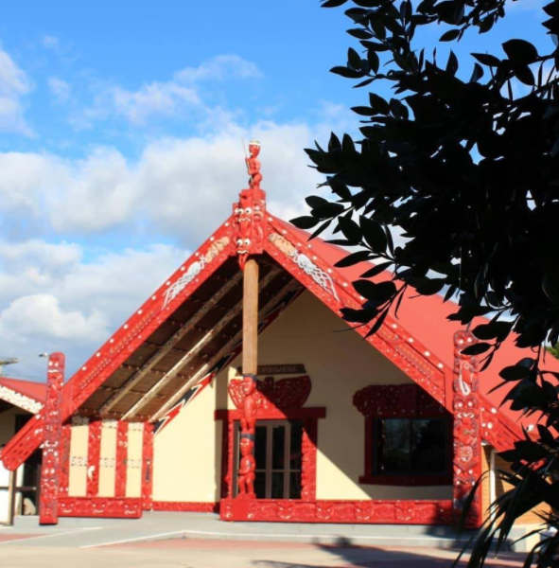
Tamateapokaiwhenua - Huria

Purpose and Introduction

The purpose of this Hapu Management Plan is to set out how the hapu will deal with development, environmental and resource management issues within the hapu rohe or where input into regional and/or national environmental issues is appropriate. It will also address how it will work with local government in respect of development and associated issues which fall within the hapu rohe.
The hapu approach will be a co-operative one on the basis that the environment is the responsibility of the whole community and many of the interests and concerns arising from the sustainable management of that environment are shared.
However Ngai Tamarawaho brings a particular cultural perspective to management of our land and environment. That perspective is based on centuries of occupation of the lands in and around the Tauranga/Te Papa peninsula, the Kopurererua Valley extending back to Puwhenua and the Kaimai range; the Waikareao Estuary and the wider harbour of Te Awanui and beyond to Karewa and Tuhua (Mayor) islands. In this respect Ngaitamarawaho is acutely aware of its kaitiaki obligations for the land and waters within its rohe.
However it also believes that the key to better environmental management is through the building of relationships with other stakeholders in Tauranga Moana. Those stakeholders include:
- local and regional government authorities

- other local and regional stakeholders including iwi and hapu

- relevant Departments of government e.g. Department of Conservation

- local business interests

- local environmental interests

- local service organisations e.g. Rotary

- Education and research bodies e.g. University of Waikato, Bay of Plenty Polytechnic – Toi Ohomai, NIWA and the Cawthron Institute; schools in our rohe

- developers

- and the wider Tauranga Moana and Western Bay of Plenty community
As a secondary outcome it is expected that this plan will assist Councils in particular by providing clear directions as to how engagement with Ngai Tamarawaho is best organised.
We also believe it will help any individual or business or other entity seeking to advance a development proposal or to engage with the hapu on the cultural and environmental issues associated with such proposals.
Ngaitamarawaho does not seek to be obstructive or adopt a negative approach to proposals or engagement requests but rather to ensure that the interests of the hapu, both cultural and environmental, are properly observed and taken into account. Where ever possible the objective is to work co-operatively towards solutions.
This plan contains the following:
  - A brief description of the hapu rohe and history

  - An outline of the hapu‘s cultural and environmental values

  - An outline of the hapu’s preferred processes and protocols for dealing with planning and development proposals within its rohe (including Resource Management issues with an emphasis on Part 2 matters)

  - Hapu consultation guidelines and contacts

Ngaitamarawaho

Ngai Tamarawaho rohe

Mai Mangorewa ki Waahinerua
The hapu rohe within which Ngai Tamarawaho holds mana whenua begins from the Te Okohanga valley, moving outward along Kaitere, Westridge, connecting along Moffats Road, in a continuous line through to Tauriko; on the east, beginning at Otamataha (in common with Ngati Tapu) on a continuous line through from Sulphur Point, inwards to encompass downtown Tauranga and outwards to take in Otumoetai and the Matua peninsula; onwards including the Te Papa peninsula through to Gate Pa and on to Te Ranga and Taumata up to and including Puwhenua maunga. The boundary adjoining Ruahine or Waimapu is on this (western) side of the Waiorahi River. (See map attached as Appendix 1) Ngai Tamarawaho also claims Karewa motu as the home of their ancestral taniwha, Taurikura, while the seaward customary boundary extends to Tuhua and beyond.

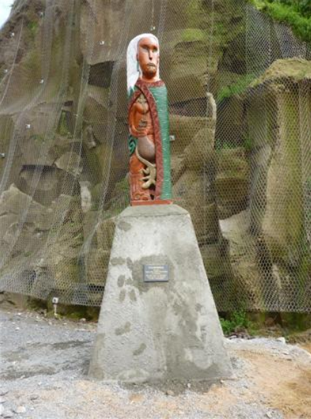
Mangorewa

Ngai Tamarawaho - descent

Ngai Tamarawaho is a hapu of Takitimu and Ngati Ranginui origin.
The line of descent is from Tamateapokaiwhenua or Tamatea Arikinui who landed from the Takitimu ancestral waka at Te Awanui (Tauranga harbour), to Ranginui and then to his grandson Te Kaponga whose pa was at Tutarawananga at the mouth of the Waimapu River across the river from Poike. The line then comes down to Tahuriwakanui whose pa Ranginui a Tamatea was at Poike; and then to his grandson Rauhea Koikoi. Their son was Kinotaraia or Tamarawaho whose pa was at Otamataha. Next in the descent line is Tuaurutapu whose pa was on Motuopae and his son Pareaoana whose pa was at Orangipani or Huria. Kinomoerua, the brother of Kinotaraia, had his pa at Otumoetai. It is through these ancestors from the Kinonui line that Ngai Tamarawaho claim mana whenua.

The hapu framework

The contemporary organisation of Ngaitamarawaho hapu is based in and around the Huria marae at Judea. The marae is the focal point for the hapu and all its activities. The affairs of the hapu are administered by various hapu entities.
An important development in relatively recent times has been the establishment of a post settlement governance entity (PSGE) the Ngai Tamarawaho Tribal Authority Trust - “NTTAT”. In conjunction with other hapu entities including the Huria Management Trust, the Marae Committee, the Kahui Kaumatua, the Ngai Tamarawaho Environmental and Development Unit – all these groups are largely responsible for the administration of hapu affairs.
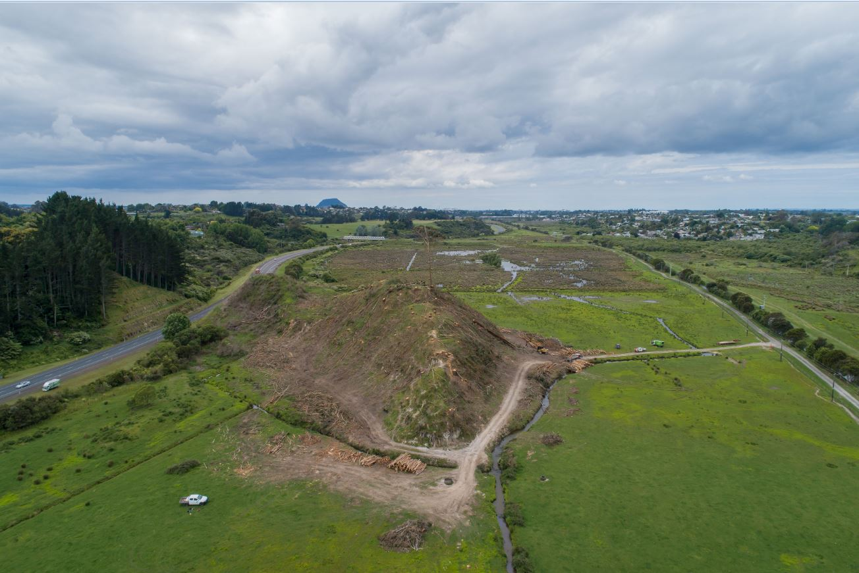
Puketoromiro – Kopurererua Valley – this pa site was completely severed by the construction of Takitimu Drive
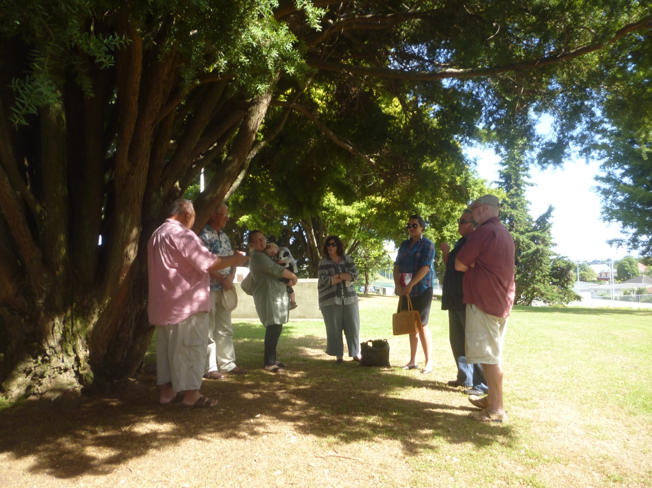
Council, church and Historic Places Trust meeting with Ngai Tamarawaho representatives to discuss Gate Pa Reserve enhancement

Cultural and Environmental values

Life values

Ngai Tamarawaho holds the following basic tenets and rights to be important and to form a basic framework for our lives that we are comfortable with:
- Respect for Te Ao Maori and all the obligations that brings

- The right to be free thinking citizens in a country that respects the laws of the land, values equality in all things, practices free speech and celebrates the principles of democracy and the Treaty of Waitangi

- The sanctity of our people and respect for their religious values and respect for the rights of all peoples to freely practise their religious beliefs

- The rights of our people to enjoy their lives in a safe and secure environment with access to proper housing/shelter; clothing and food.

- Respect for our old people who hold the wisdom of our past and for our children who hold the keys to our future

- The rights of our people to enjoy good health and to receive proper medical care and attention when needed

- The rights of our people to a sound education that meets their aspirations

- The rights of our people to enjoy the dignity of work

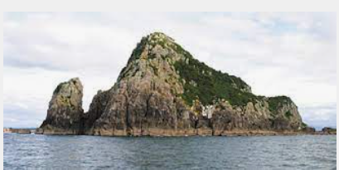
Kārewa

Cultural values

Within this basic framework Ngai Tamarawaho holds the following cultural values:

- Respect for ourselves as Maori people with a valued historic heritage that is our inheritance

- Respect for the active practice of our culture through the observance of proper tikanga and protocols that guide our lives including the rituals of the powhiri and the tangi; the use of te reo rangatira, waiata, pepeha, whakapapa, pakiwaitara, kapa haka, poi and the many things that distinguish us as Ngai Tamarawaho.

- Respect and reverence for all the places that are important to us; including the cultural landscape that we live in – mountains, waterways, islands, moana – the sea, our traditional lands. All these things are permanent reminders of who we are as a people and help identify our place in that landscape

- Respect for our ancestral marae, our remaining lands and our homes because they constitute our turangawaewae – our place to stand

- Respect for the burial places of our dead, the ancestors from whom we have sprung and who provided these places for us

- Respect for our hapu, Ngaitamarawaho and its constituent whanau – we are the strong foundations from which our people go out to face the world

- Respect for the alliances and shared experiences that join us to other hapu and iwi of Tauranga Moana and to other hapu and iwi that share our allegiance to the Kingitanga
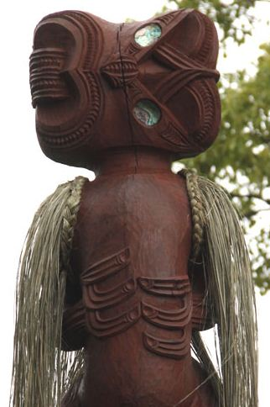

Environmental values

These cultural values are reflected in our environmental values which are set within a holistic world framed by Rangi – the sky, Papatuanuku – the earth and Tangaroa – the sea.

The cultural landscape, traditional lands, waters and the other ancestral taonga that have been handed down to us have placed an obligation on us – the present generation – to act as kaitiaki, guardians of these things to ensure that what we pass to the next generation is not diminished but rather has been enhanced by our kaitiaki tenure.

Air

The air that we breathe is a basic of life. We believe it should be kept clean, free from harmful pollutants and properly safeguarded when activities are of a nature that causes a temporary change in its nature e.g. dust caused by building or road construction. There should be no discharge to air that does not meet necessary standards and all options should be explored to avoid, mitigate or remedy any such discharges.
Ngaitamarawaho expects to be consulted in all cases where a proposal or development anywhere within its rohe seeks to make discharges to air.

Land

The land of our rohe is our turangawaewae – our place to stand. It also holds the history of our past and is an important key to our future. We have a sacred obligation to ensure that the lands within our rohe are treated with respect.
Ngaitamarawaho expects to be consulted and be an active participant in all cases where a proposal or development involves earthworks, discharges to land, or is land that holds a special cultural significance for our people such as past burial grounds, places where our people formerly lived and places of spiritual significance.

Water

All the waterways and water sources within our rohe – large or small – are important to us. We mention in particular the Kopureroa Stream, the Waikareao Estuary, the Tauranga harbour, the Moana A Toi itself and the offshore island of Karewa. The sea and the waterways have nurtured our people – they have formed our pathways, have been places of sustenance for us for generations whether that be for drinking water – wai Maori – or as with the estuary and the harbour and sea - our food bowl and garden. Karewa is the home of our ancestor Taurikura.
We have a kaitiaki obligation to ensure and where possible enhance the water quality of our waterways and to protect and preserve all the life that is within those waters and places. Enhancement of the waterways includes proper use and care of the surrounding environment.
We are aware that our harbour and our estuary in particular are subject to unauthorised discharges or untreated discharges from many point sources. These discharges have, among other things, contributed a surfeit of nutrients to the water creating a low quality marine environment. In turn that has had a serious and negative impact on the mauri - the spiritual element or life essence that exists in all things – associated with those places. Working with other stakeholders, even if incrementally, Ngaitamarawaho wants to restore our waterways, our estuary and harbour.
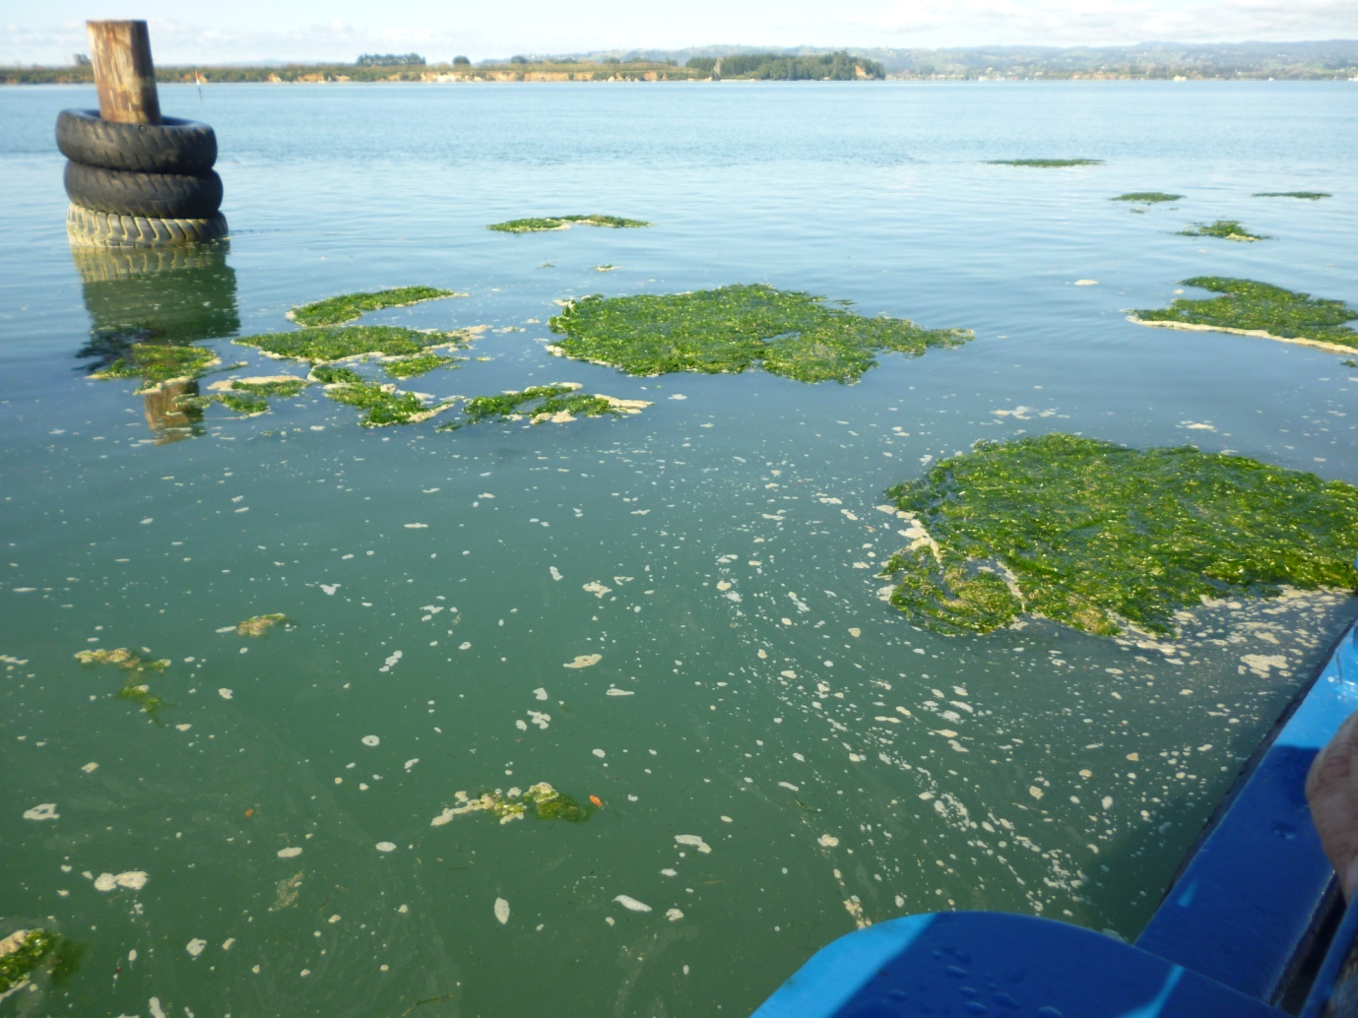
Sea lettuces – ulva lactuca – in Te Awanui – the annual summer blooms are the result of too much nutrient content in the water – indicating run off from land problems - how to combat this?
Ngaitamarawaho expects to be consulted and be an active participant in all cases where a proposal or development involves engagement in any way with our waterways – the Kopureroa Stream in particular, the Waikareao Estuary, Te Awanui - Tauranga harbour, Moana A Toi and the waters surrounding Karewa.

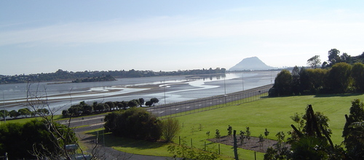
Motuopae (hapu urupa) and Waikareao Estuary

Engagement

In engaging with Ngaitamarawaho the first expectation is that initial contact will be followed by a face to face meeting – kanohi ki kanohi. Contact details are set out below.
It should be noted that while Ngaitamarawaho have access to officers experienced in planning and best resource management practice as they apply to cultural and environment related issues, the hapu reserves the right to engage professional, technical or legal advice as necessary.

Contact details:
Buddy Mikaere (+6421384620)
Director
Ngai Tamarawaho Environmental and Development Unit
PO Box 141 Coromandel 3506
buddy@buddymikaere.com

For any other matters involving the hapu and Huria Marae in particular
Sylvia Willison
General Manager
Huria Management Trust (07 5787838)
Huria Marae
4 Te Kaponga Street Judea
PO Box 398 TAURANGA
sylvia.willison@huriamanagement.co.nz

Summary

Ngaitamarawaho takes its kaitiaki obligations very seriously while also believing that it has a positive contribution to make in the management of the environment it shares with the rest of the community.
The key point being made here is the desire to be involved in anything affecting the taiao but which for the purposes of this document have been restricted to the three main environmental areas of air, land and water.

Ngaitamarawaho Principles and Protocols

Treaty Principles

In its relationships with all other parties Ngai Tamarawaho has an expectation that Te Tiriti O Waitangi will be recognised by those parties as the founding document of Aotearoa, New Zealand.
There is a further expectation that Ngai Tamarawaho and all the parties with whom it has formal or informal relationships agree to the following understanding of Treaty principles:
- Principle of Tino Rangatiratanga – Self Management – The right of Maori to exercise under the law, authority and control over their rohe, land, rivers, resources and taonga.

- Principle of Kawanatanga – Governance – The government has the right to make laws for the good order and security of the country subject to the duty imposed (on the Crown) to Maori under the Treaty.

- Principle of Whakawhanautanga – Partnership – A duty on both iwi/hapu and all relationship parties to interact in the best possible way with reason, respect and in good faith.

- Principle of Oritetanga – Equality – The right of tangata whenua to fair and equal treatment under the law.

- Principle of Kaitiakitanga – Guardianship – The right of Maori to exercise guardianship over their ancestral lands, water, sites, waahi tapu and other taonga.

- Principle of ‘He here kia mohio’ – Cooperation and consultation – The duty to listen to what others have to say, consider their responses and then decide what will be done.

- Principle of Whakatika i te he – Redress Past Breaches – The duty of the Crown to work towards settlement of grievances under the Treaty of Waitangi.

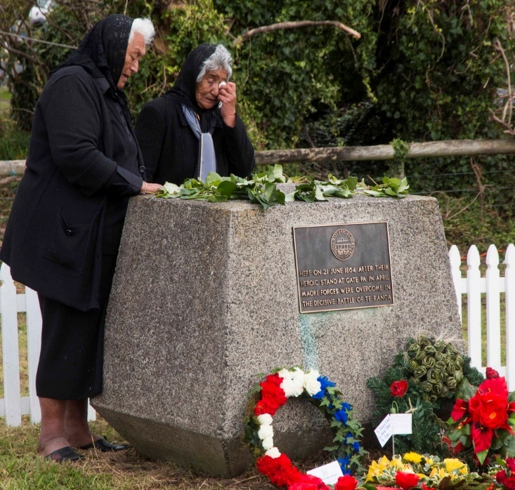

Te Ranga battle site

Relationship Principles

Ngai Tamarawaho requires that its relationships with other parties be based on the following principles:
- Both parties seek to provide for the cultural, social, economic and environmental well-being of their respective communities in the present and for the future;
- Both parties will act in utmost good faith
- The relationship shall be built on honesty and integrity and shall be fair and equitable and maintained in a spirit of friendship and co-operation
- Ngai Tamarawaho is recognised as kaitiaki for their rohe and has mana whenua over that rohe.
- Ngai Tamarawaho’s relationship with its culture and traditions with respect to the iwi/hapu ancestral lands (.e.g. maunga, pa sites), water bodies (e.g. moana, awa and roto) sites of significance including sites recorded on national and local GIS and other records, waahi tapu and other taonga and the need to protect these.
- Ngai Tamarawaho is recognised as having an inherent right to contribute to the decision making processes which affect their rohe.

Representation

Ngai Tamarawaho will be responsible for the appointment of its representative(s) to represent the hapu in its relationships with other organisations.
It should be recognised that individuals, incorporations, land trust etc, within the rohe are not mandated to speak on behalf of the hapu, make decisions or enter into agreements (formal or otherwise) that affect the hapu.
The person or persons mandated to speak for the hapu will be advised in writing from time to time as will any changes to that person or persons.
It is recognised that Ngai Tamarawaho representatives are accountable to the hapu of Ngai Tamarawaho. It is the responsibility of the representatives to report back and be guided by the direction and responses at hui a iwi/hapu.
Ngai Tamarawaho will take responsibility to ensure that their representative(s) report back to the hapu, particularly where there are agreed timeframes to be met.

The current mandated hapu representatives are:
Des Tata and Peri Kohu – Te Rangapu Mana Whenua (TCC)
Peri Kohu and Sylvia Willison – Tangata Whenua Forum (WBOPDC)
Des Tata and Buddy Mikaere – Smartgrowth
All other communications, first points of contact etc.
Buddy Mikaere
Huria Marae, Kahui Kaumatua, Health and Education
Sylvia Willison

Conflicts of Interest of Individuals

In respect of its dealings with other parties Ngai Tamarawaho agree that as far as possible conflicts of interest will be avoided. Some instances where conflicts of interest may occur include situations in which:
- An individual’s personal interests may affect that individual’s judgement in acting in the best interest of the hapu
- The issue may give rise to an individual or the individual’s whanau receiving a financial benefit
- The individual’s interest is greater than the interests of the hapu
- This document does not prejudice the tino rangatiratanga of Ngai Tamarawaho

FOR THE FUTURE

Infrastructure and public spaces

Ngai Tamarawaho has a development concept for the Kopurererua Valley and stream which the hapu looks to develop in partnership with other stakeholders. The vision is to create within the valley and stream an ecological and cultural “island” that offers open space with enhanced public access and which links naturally to the walkways and cycle paths around the Waikareao Estuary.
A similar approach is envisaged in relation to the Pukehinahina – Gate Pa and Te Ranga Historical Reserves in Gate Pa and Pyes Pa. The hapu looks to work with other stakeholders in turning these significant reserves into historical precincts that reflect the importance of the sites. The public access reserves – Te Ranga in particular - will also provide a landscaping design opportunity to show, by way of appropriate plantings, a small portion of the original forest cover.
Other public spaces in which Ngaitamarawaho looks for meaningful involvement include the Waikareao walkway, the Strand Extension to Memorial Park walkway, Otamataha (Mission Cemetery), Masonic Park, the Civic precinct and Tauranga CBD in general, Wharepai (Tauranga) Domain, Monmouth Redoubt and the Cliff Road Precinct, Memorial Park, Otumoetai Pa reserve and the TECT All Terrain Park.
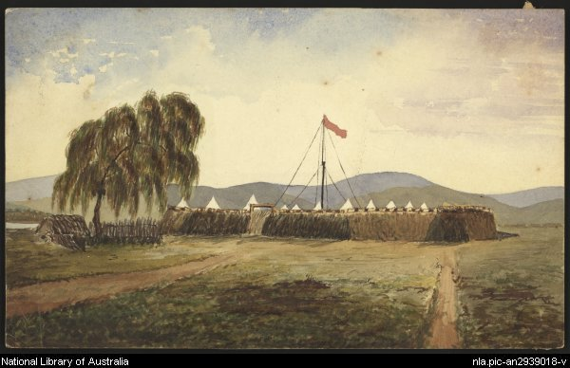
The Judea Redoubt 1864-66

Ngaitamarawaho also looks to make a contribution on planning and cultural aspects into the redevelopment proposals for the Tauranga CBD waterfront area along The Strand and Dive Crescent; the latter in partnership with Tauranga City Council via the Otamataha Trust.

THIS HAPU MANAGEMENT PLAN

It is intended that this plan be reviewed and if necessary, updated, on an annual basis aligned with the hapu annual reporting cycle. Contributions or suggestions in respect of the plan contents are invited.

APPENDICES

APPENDIX 1 – NGAI TAMARAWAHO ROHE

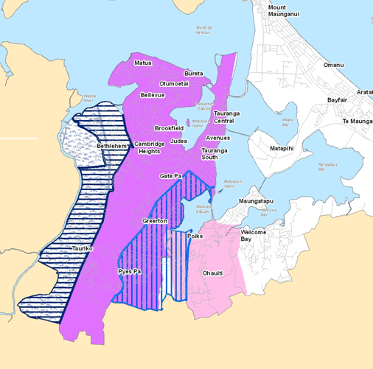

LEGEND
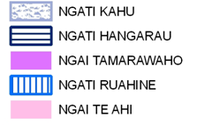

APPENDIX 2 - Ngai Tamarawaho sites of significance

These are the Ngai Tamarawaho sites of significance – The list is not exhaustive and may be added to from time to time.
- Motuopae (Urupa)

- Waikareao Estuary and the estuary fringe

- Oreanui

- Kopurererua Valley and stream (Puketoromiro and Orini Pa sites)

- Matua Iwi (Matua and Oreanui Pa sites)

- Otamataha Pa site (in partnership with Ngati Tapu)

- Mauao (Ruarapapari and Kinonui Pa sites)

- Marawaewae (Tauranga Race course)

- Pukehinahina & Te Ranga battle sites

- Taumata

- Puwhenua Maunga

- Karewa and Tuhua Islands

This document prepared by Ngai Tamarawaho Environmental and Development Unit for Ngai Tamarawaho with funding provided by the Western Bay of Plenty District Council

Where kaitiaki means guardianship or stewardship; kaitiakitanga is defined in the Resource Management Act 1991 as “the exercise of guardianship by the tangata whenua of an area in accordance with tikanga Maori in relation to natural and physical resources and includes the ethic of stewardship”. Section 7(a) of Part 2 of the Act provides opportunities for tangata whenua, through the practical expression of kaitiakitanga, to be involved in managing the use, development and protection of their ancestral taonga.
Mana whenua refers to the people able to whakapapa to the land in question and who in Maori tikanga terms therefore hold the right to speak for that land.
Rohe means tribal area. It is recognised that in some instances more than one iwi/hapu has interests where rohe overlap.
Waahi tapu is a place of special significance according to Ngai Tamarawaho history and tikanga. See Part 2, section 6(e) of the RMA.
For example as per section 81(1) (a) – (c) of the Local Government Act 2002

